O Trinity of blessed light Hymnal 1982 no. 30 Melody: O lux beata Trinitas L.M.
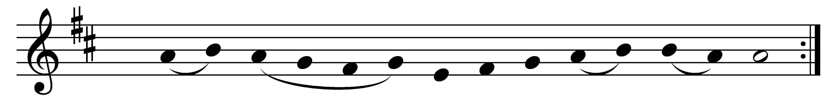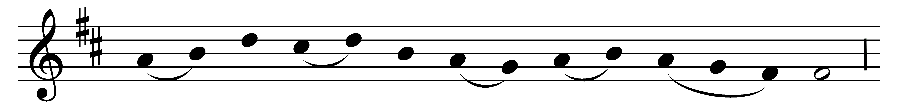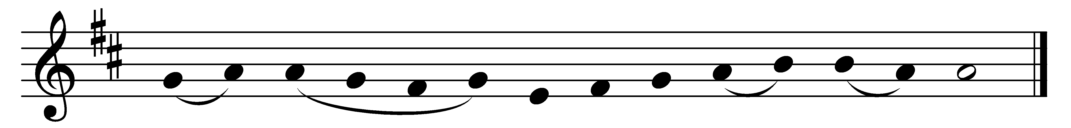

O Trinity of blessèd light,
O Unity of princely might,
the fiery sun now goes his way;
shed thou within our hearts thy ray.

To thee our morning song of praise,
to thee our evening prayer we raise;
O grant us with thy saints on high
to praise thee through eternity.

To God the Father, heavenly Light,
to Christ revealed in earthly night,
to God the Holy Ghost we raise
our equal and unceasing praise.

Words: 6th-century Latin, translated by John Mason Neale (1818-1866); v. 3 by Charles Coffin (1676-1749), translated by John Chandler (1806-1876)
Music: Mode viii

