O Food to pilgrims given Hymnal 1982 no. 308 Melody: Psalm 6 7 7 6. D.
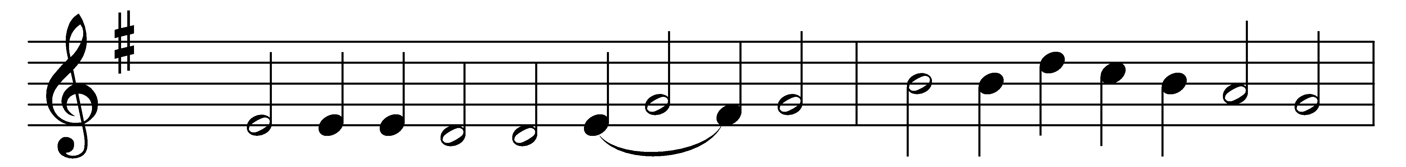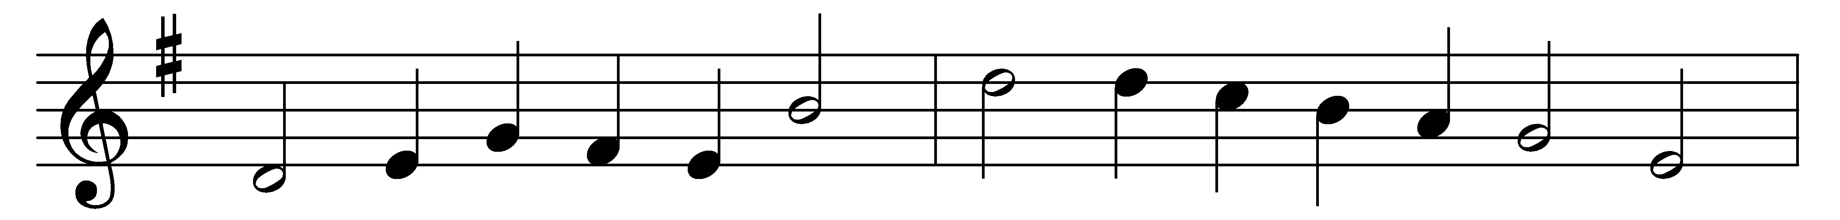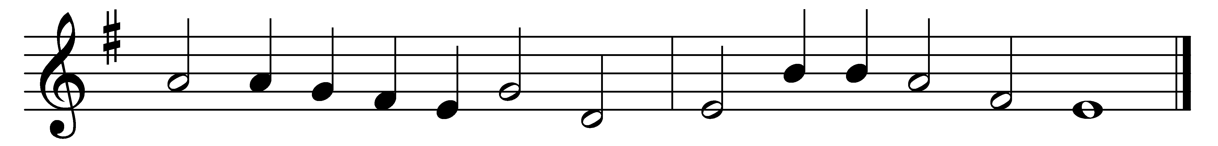

O Food to pilgrims given,
O Bread of life from heaven,
O Manna from on high!
We hunger; Lord, supply us,
nor thy delights deny us,
whose hearts to thee draw nigh.

O stream of love past telling,
O purest fountain, welling
from out the Savior’s side!
We faint with thirst; revive us,
of thine abundance give us,
and all we need provide.

O Jesus, by thee bidden,
we here adore thee, hidden
in forms of bread and wine.
Grant when the veil is riven,
we may behold, in heaven,
thy countenance divine.

Words: Latin, 1661, translated by John Athelstan Laurie Riley (1858-1945)
Music: From Les cent cinquante Pseaumes de David, 1564

