Praise to God, immortal praise Hymnal 1982 no. 288 Melody: Dix 7 7. 7 7. 7 7.
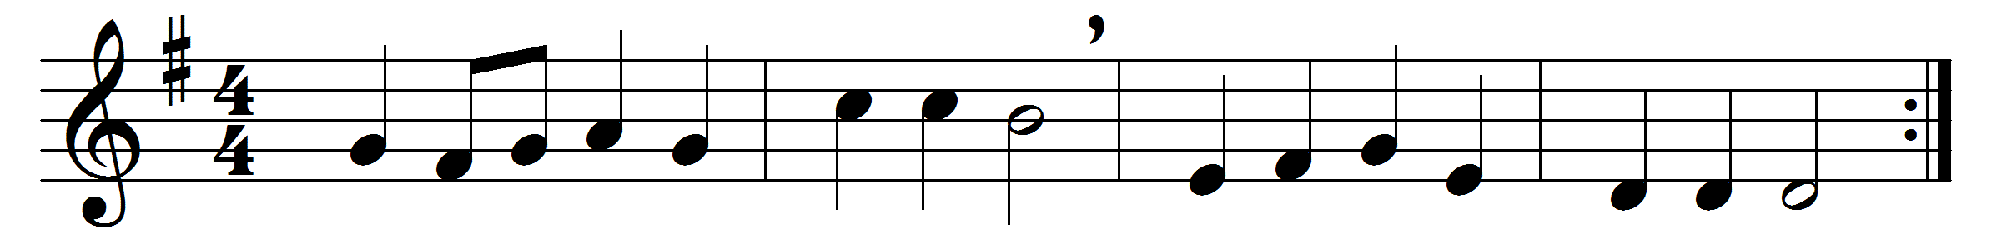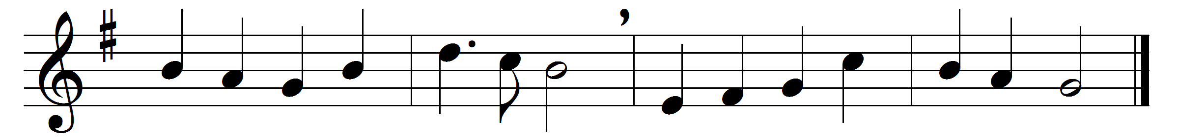

Praise to God, immortal praise,
for the love that crowns our days;
bounteous source of every joy,
let thy praise our tongues employ:
all to thee, our God, we owe,
source whence all our blessings flow.

All the plenty summer pours;
autumn’s rich o’erflowing stores;
flocks that whiten all the plain;
yellow sheaves of ripened grain:
Lord, for these our souls shall raise
grateful vows and solemn praise.

As thy prospering hand hath blessed,
may we give thee of our best;
and by deeds of kindly love
for thy mercies grateful prove;
singing thus through all our days
praise to God, immortal praise.

Words: Anna Laetitia Barbauld (1743-1825)
Music: Adapted from Conrad Kocher (1786-1872) by William Henry Monk (1823-1889)

