What thanks and praise to thee we owe Hymnal 1982 no. 285
Melody: Deus tuorum militum (Grenoble) L.M.
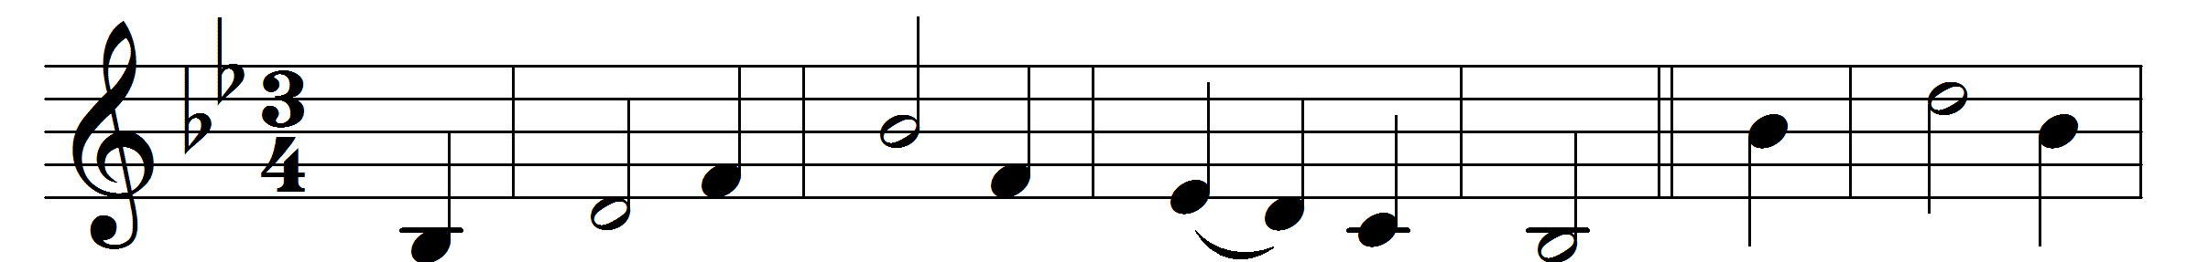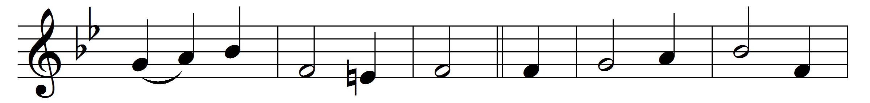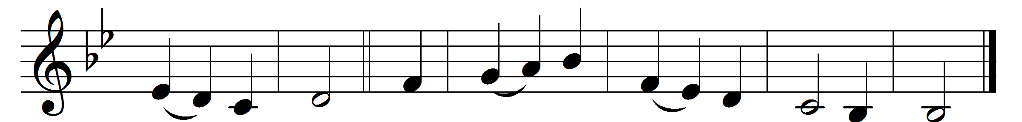

What thanks and praise to thee we owe,
eternal God and Word divine,
for Luke, thy saint, through whom we know
so many gracious words of thine.

O happy saint! his sacred page,
so rich in words of truth and love,
pours on the Church from age to age
the healing unction from above.

Historian of the Savior’s life,
the great apostle’s chosen friend,
through weary years of toil and strife
was still found faithful to the end.

So grant us, Lord, like him to live,
beloved on earth, approved by thee,
till thou at last the summons give,
and we, with him, thy face shall see.

Words: William Dalrymple Maclagan (1826-1910)
Music: Melody from Grenoble Antiphoner, 1753

