God of saints, to whom the number Hymnal 1982 no. 280 Melody: Halton Holgate 8 7. 8 7.
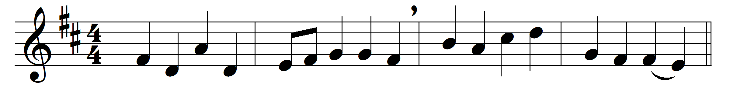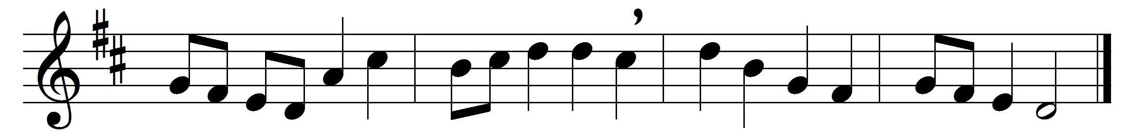

God of saints, to whom the number
of the starry host is known:
many saints by earth forgotten
live for ever round your throne.

In the roll of your apostles
stands the name Bartholomew,
for this faithful saint we offer,
year by year, our thanks to you.

All his faith and prayer and patience,
all his toiling and his strife,
all are veiled from us, but written
in the Lamb’s great book of life.

There are named the blessed faithful
of the new Jerusalem.
When Christ comes again in glory,
number us, we pray, with them.

Words: John Ellerton (1826-1893)
Music: Later form of melody by William Boyce (c. 1710-1779)

