For thy dear saints, O Lord Hymnal 1982 no. 279 Melody: St. George S.M.

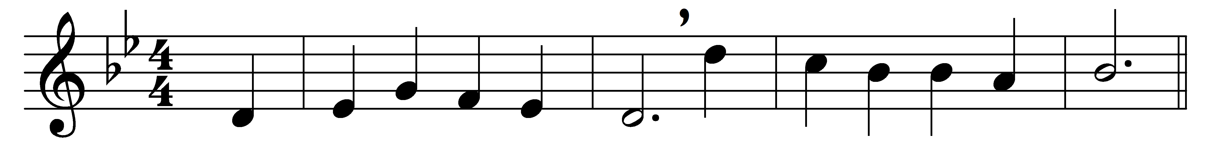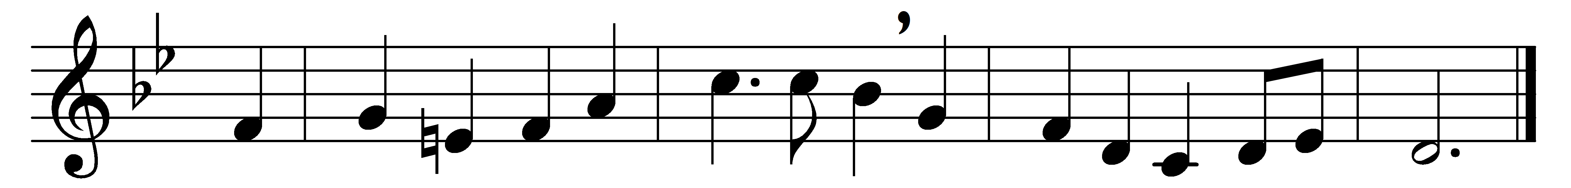

For thy dear saints, O Lord,
who strove in thee to live,
who followed thee, obeyed, adored,
our grateful hymn receive.

They all in life and death,
with thee their Lord in view,
learned from thy Holy Spirit’s breath
to suffer and to do.

Thine earthly members fit
to join thy saints above,
in one communion ever knit,
one fellowship of love.

Jesus, thy Name we bless,
and humbly pray that we
may follow them in holiness,
who live and died for thee.

Words: Richard Mant (1776-1848)
Music: Henry John Gauntlett (1805-1876)

