Hark! the sound of holy voices Hymnal 1982 no. 275 Melody: In Babilone 8 7. 8 7. D.

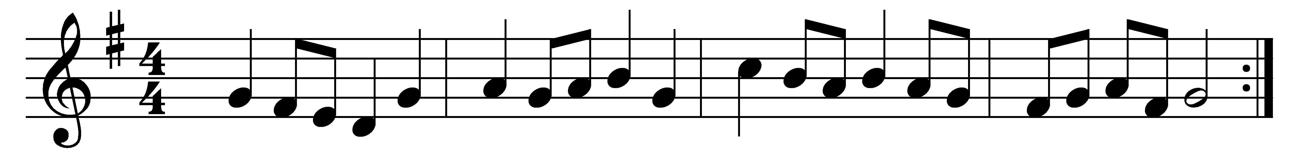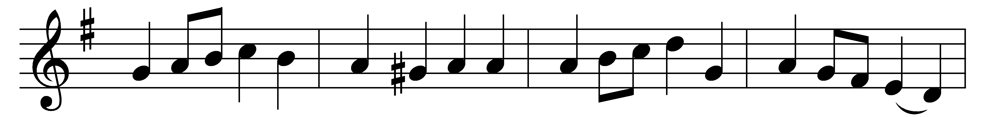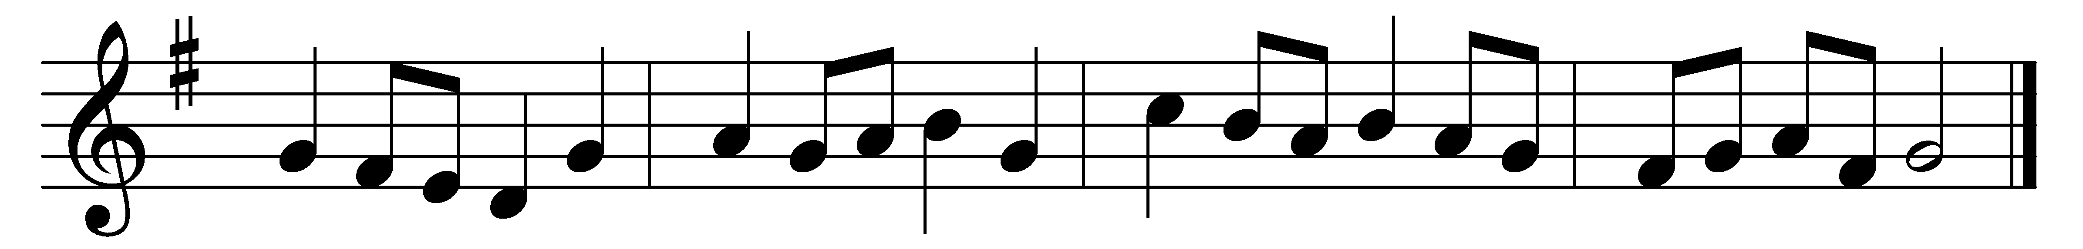

Hark! the sound of holy voices,
chanting at the crystal sea,
Alleluia, alleluia,
alleluia! Lord, to thee!
Multitude which none can number
like the stars in glory stands,
clothed in white apparel, holding
palms of victory in their hands.

Patriarch, and holy prophet,
who prepared the way for Christ,
king, apostle, saint, confessor,
martyr and evangelist,
saintly maiden, godly matron,
widows who have watched to prayer,
joined in holy concert, singing
to the Lord of all, are there.

Marching with thy cross, their banner,
they have triumphed following
thee, the Captain of salvation,
thee, their Savior and their King.
Gladly, Lord, with thee they suffered;
gladly, Lord, with thee they died;
and by death to life immortal
they were born and glorified.

Now they reign in heavenly glory,
now they walk in golden light,
now they drink, as from a river,
holy bliss and infinite;
love and peace they taste for ever,
and all truth and knowledge see
in the beatific vision
of the blessed Trinity.

Words: Christopher Wordsworth (1807-1885)
Music: Melody from Oude en Nieuwe Hollantse Boerenlities en Contradansen, 1710

