Praise we the Lord this day Hymnal 1982 no. 267 Melody: St George S.M.
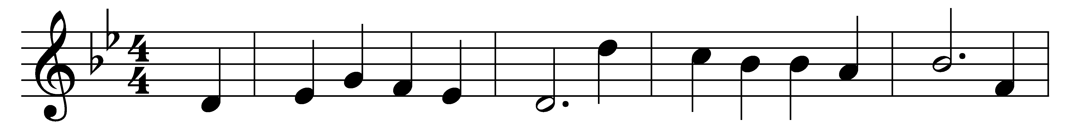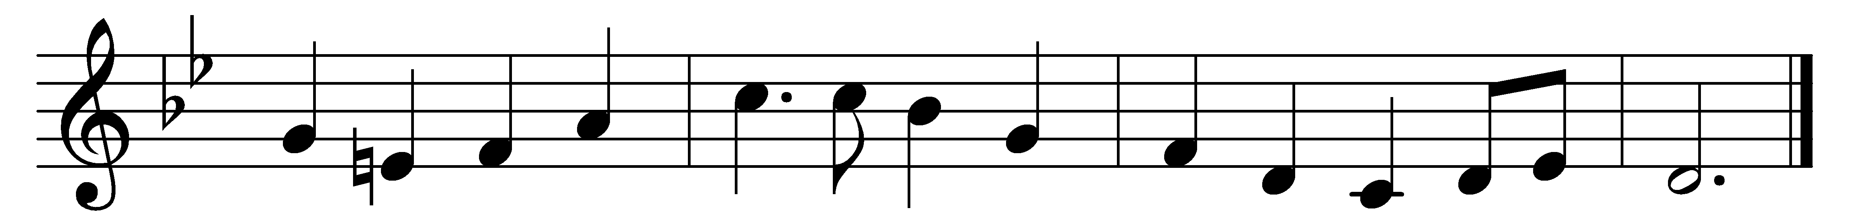

Praise we the Lord this day,
this day so long foretold,
whose promise shone with cheering ray
on waiting saints of old.

The prophet gave the sign
for faithful folk to read:
a virgin born of David’s line
shall bear the promised seed.

Ask not how this should be,
but worship and adore,
like her whom heaven’s Majesty
came down to shadow o’er.

She meekly bowed her head
to hear the gracious word,
Mary, the pure and lowly maid,
the favored of the Lord.

Most blest shall be her name
in all the Church on earth,
through whom that wondrous mercy came,
th’ incarnate Savior’s birth.

Words: Anonymous, from Hymns for the Festivals and Saints’ Days of the Church of England, 1846
Music: Henry John Gauntlett (1805-1876)

