Virgin-born, we bow before thee Hymnal 1982 no. 258 Melody: Psalm 86 8 8. 7 7. D.
Words from AMNS
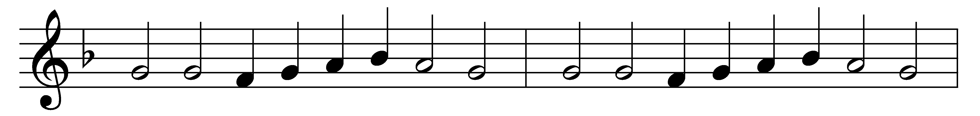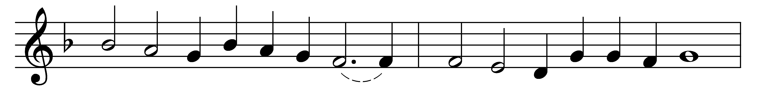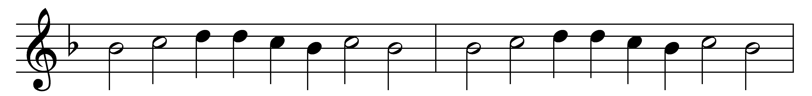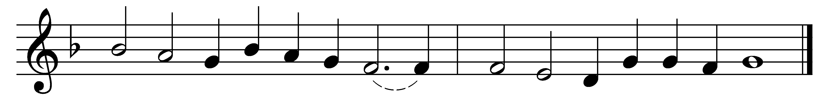

Virgin-born, we bow before thee:
blessèd was the womb that bore thee;
Mary, maid and mother mild,
blessèd was she in her child.
Blessèd was the breast that fed thee;
blessèd was the hand that led thee;
blessèd was the parent’s eye
that watched thy slumbering infancy.

Blessèd she by all creation,
who brought forth the world’s Salvation;
blessèd they, for ever blest,
who love thee most and serve thee best.
Virgin-born, we bow before thee:
blessèd was the womb that bore thee;
Mary, maid and mother mild,
blessèd was she in her child.

Words: Reginald Heber (1783-1826)
Music: Claude Goudimel (1514-1572)

