Virgin-born, we bow before thee Hymnal 1982 no. 258 Melody: Psalm 86 8 8. 7 7. D.
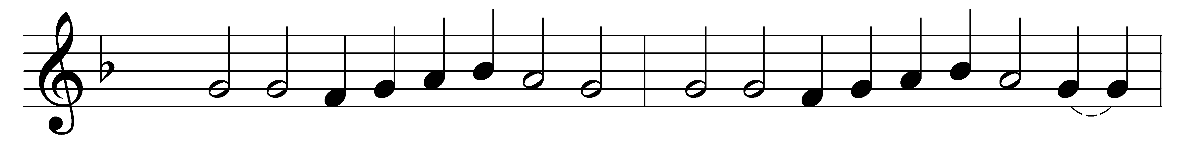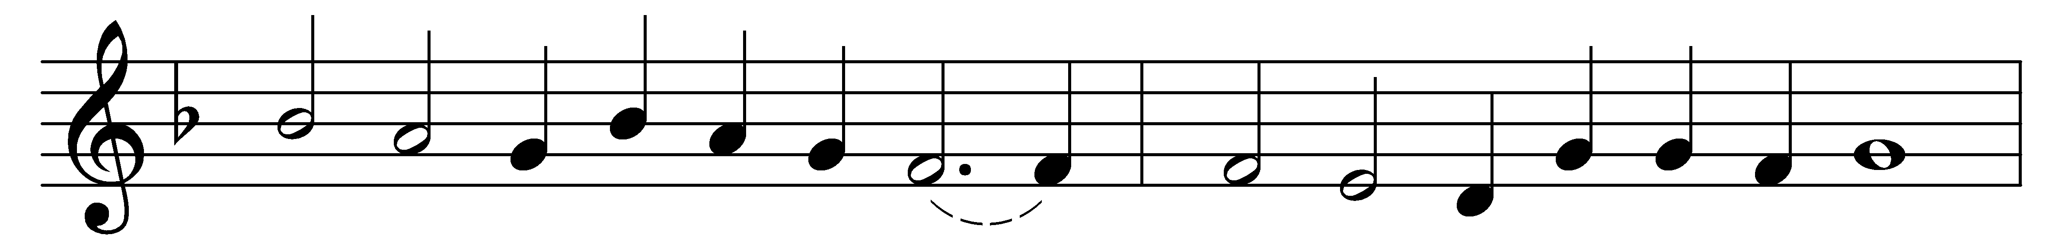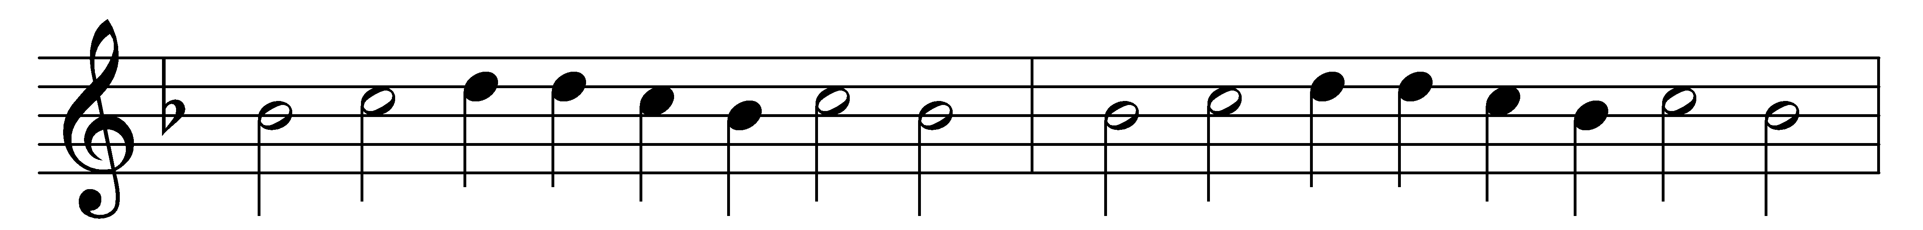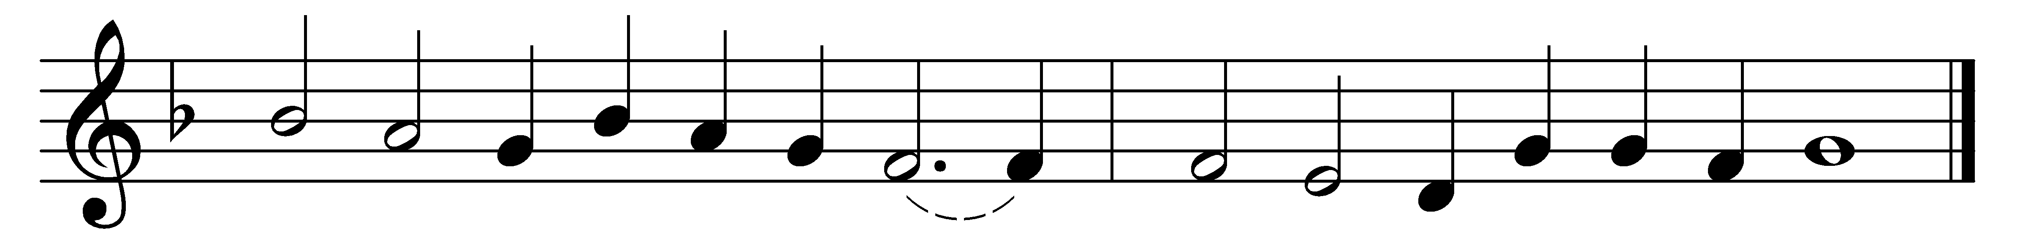

Virgin-born, we bow before thee:
blessèd was the womb that bore thee;
Mary, Mother meek and mild,
blessèd was she in her Child.
Blessèd was the breast that fed thee;
blessèd was the hand that led thee;
blessèd was the parent’s eye
that watched thy slumbering infancy.

Blessèd she by all creation,
who brought forth the world’s salvation,
and blessèd they, for ever blest,
who love thee most and serve thee best.
Virgin-born, we bow before thee;
blessèd was the womb that bore thee;
Mary, Mother meek and mild,
blessèd was she in her Child.

Words: Reginald Heber (1783-1826)
Music: Claude Goudimel (1514-1572)

