We sing the glorious conquest Hymnal 1982 no. 255 Melody: Munich 7 6. 7 6. D.
Words from AMNS
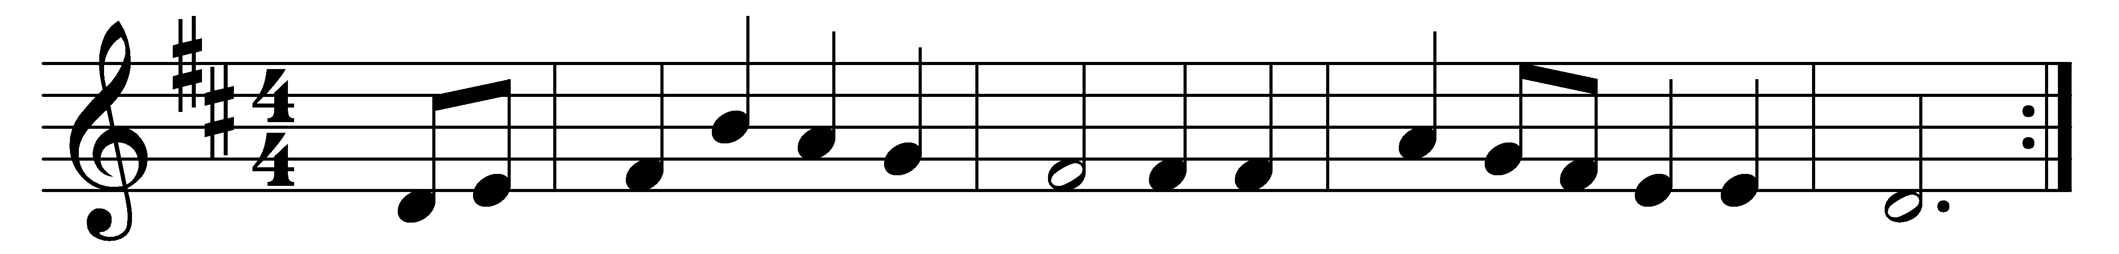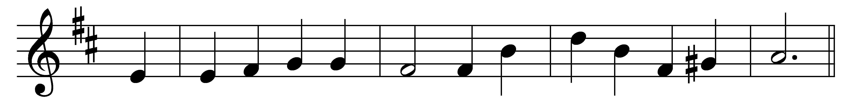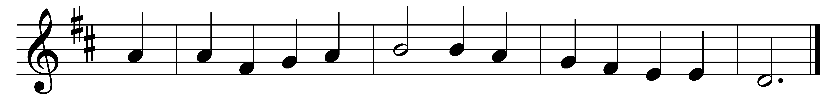

We sing the glorious conquest
before Damascus’ gate,
when Saul, the Church’s spoiler,
came breathing threats and hate;
the ravening wolf rushed forward
full early to the prey;
but lo, the Shepherd met him,
and bound him fast to-day.
O glory most excelling
that smote across his path!
O light that pierced and blinded
the zealot in his wrath!
O voice that spake within him
the calm reproving word!
O love that sought and held him
the bondman of his Lord!
O Wisdom, ordering all things
in order strong and sweet,
what nobler spoil was ever
cast at the Victor’s feet?
what wiser master-builder
e’er wrought at thine employ
than he, till now so furious
thy building to destroy?
Lord, teach thy Church the lesson,
still in her darkest hour
of weakness and of danger
to trust thy hidden power:
thy grace by ways mysterious
the wrath of man can bind,
and in thy boldest foeman
thy chosen saint can find.

Words: John Ellerton (1826-1893)
Melody: From Neu-vermehrtes und zu Übung Christl. Gottseligkeit eingerichtetes Meiningisches Gesangbuch, 1693, adapted and harmonised by Felix Mendelssohn (1809-1847)

