Jesus! Name of wondrous love! Hymnal 1982 no. 252 Melody: Louez Dieu 7 7. 7 7.
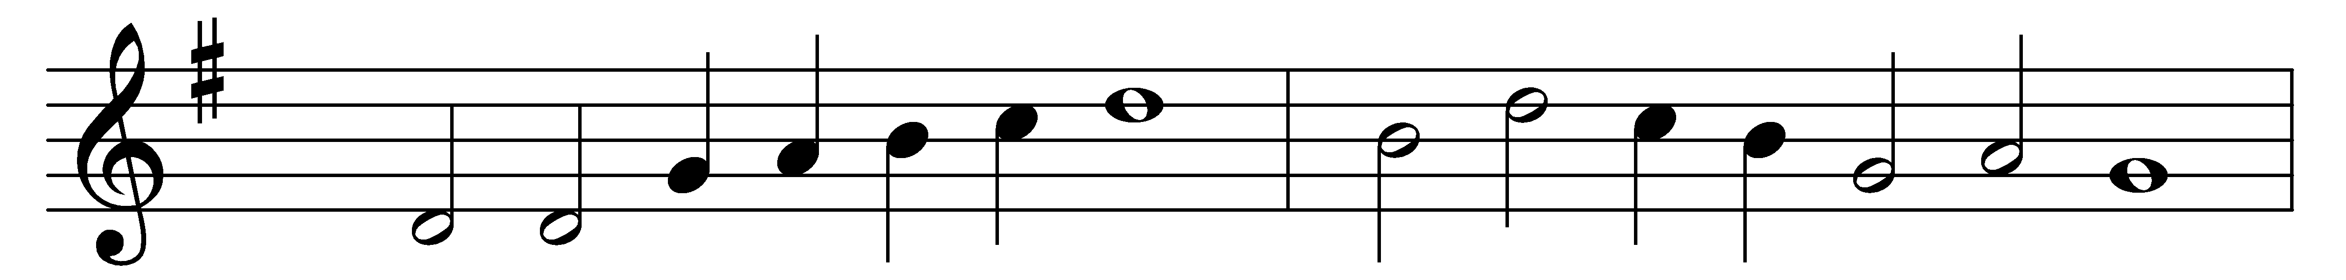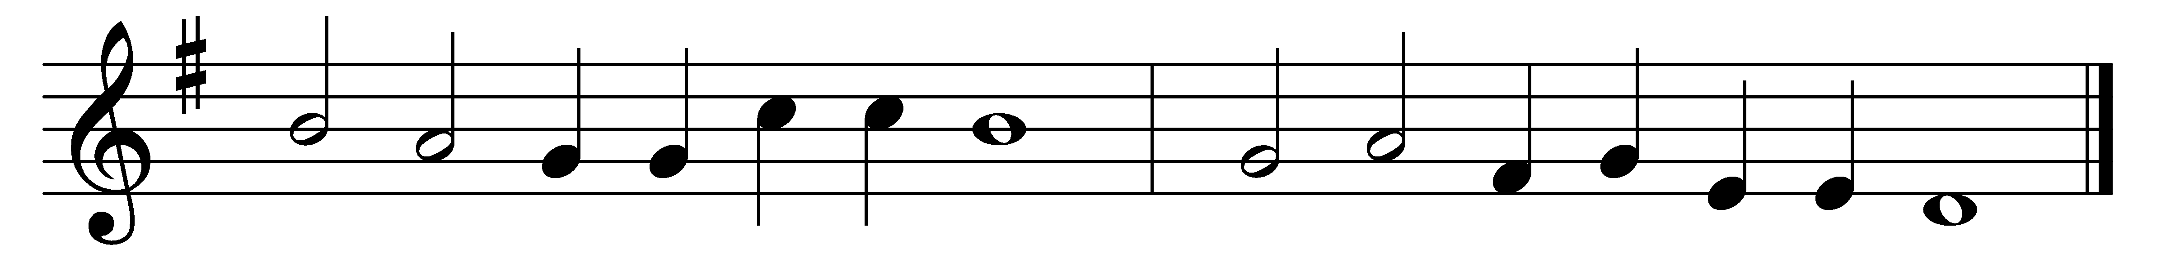

Jesus! Name of wondrous love!
Name all other names above!
Unto which must every knee
bow in deep humility.

Jesus! Name decreed of old,
to the maiden mother told,
kneeling in her lowly cell,
by the angel Gabriel.

Jesus! Name of priceless worth
to the fallen of the earth,
for the promise that it gave,
‘Jesus shall his people save.’

Jesus! Name of mercy mild,
given to the holy child
when the cup of human woe
first he tasted here below.

Jesus! only Name that’s given,
under all the mighty heaven,
whereby those to sin enslaved,
burst their fetters and are saved.

Jesus! Name of wondrous love!
Human Name of God above;
pleading only this we flee,
helpless, O our God, to thee.

Words: William Walsham How (1823-1897)
Music: From Les cent cinquante Pseaumes de David, 1564

