O God, whom neither time nor space Hymnal 1982 no. 251 Melody: London New C.M.
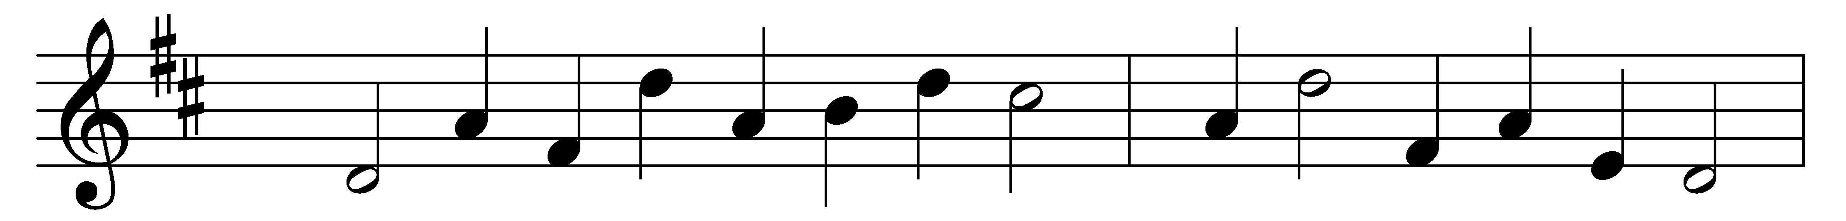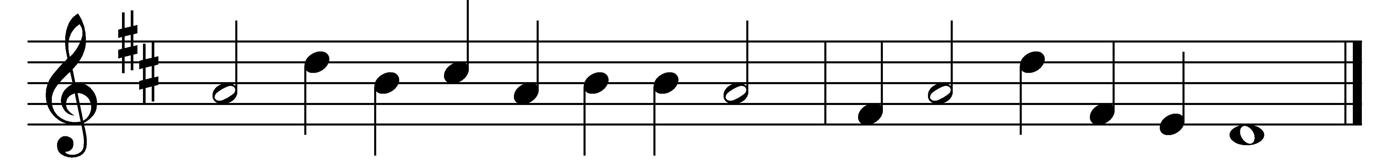

O God, whom neither time nor space
can limit, hold, or bind,
look down from heaven, thy dwelling-place,
with love for humankind.

Another year its course has run;
thy loving care renew:
forgive the ill that we have done,
the good we failed to do.

In doubt or danger, all our days,
be near to guard us still;
let all our thoughts and all our ways
be governed by thy will.

O help us here on earth to live
from selfish passions free;
to us at last in mercy give
eternal life with thee.

Words: Horace Smith (1836-1922) and others
Music: Melody from The Psalmes of David in Prose and Meeter (1635), harmonised by John Playford (1623-1686)

