Hearken to the anthem glorious Hymnal 1982 no. 241 Melody: Laus Deo 8 7. 8 7.
British spelling
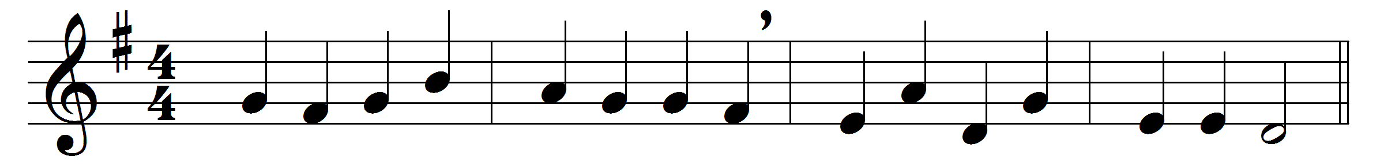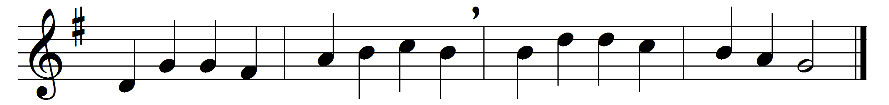

Hearken to the anthem glorious
of the martyrs robed in white;
they, like Christ, in death victorious
dwell for ever in the light.

Living, they proclaimed salvation,
heaven-endowed with grace and power;
and they died in imitation
of their Saviour’s final hour.

Christ, for cruèl traitors pleading,
triumphed in his parting breath
o’er all miracles preceding
his inestimable death.

Take from him what ye will give him,
of his fulness grace for grace;
strive to think him, speak him, live him,
till you find him face to face.

Words: Christopher Smart (1722-1771)
Music: Richard Redhead (1820-1901)

