Blessed feasts of blessed martyrs Hymnal 1982 no. 239 Melody: Alta Trinità beata 8 7. 8 7. D.
British spelling
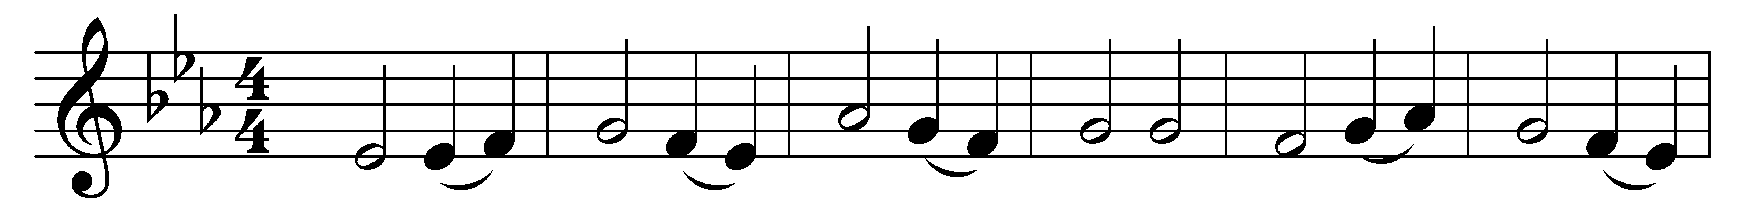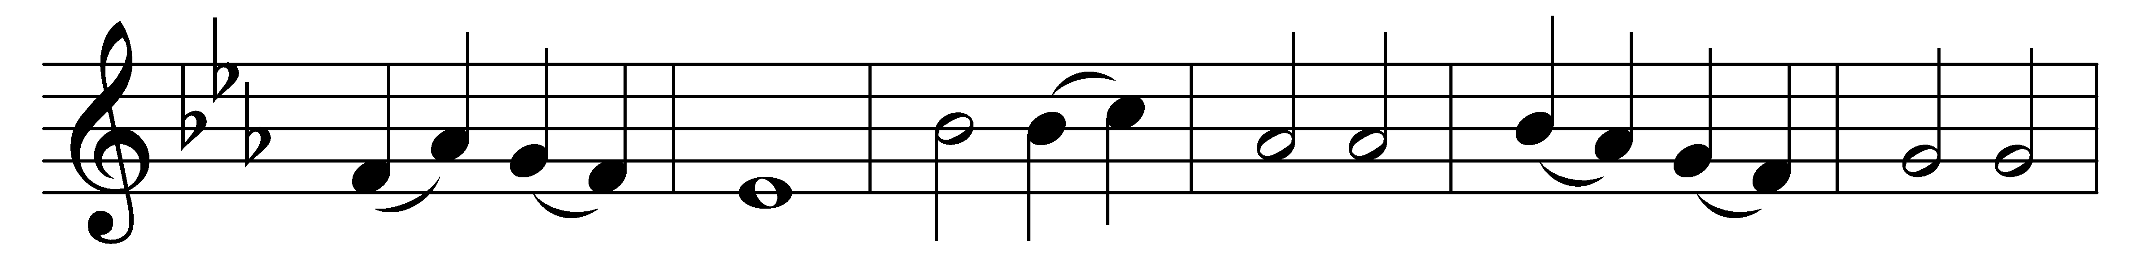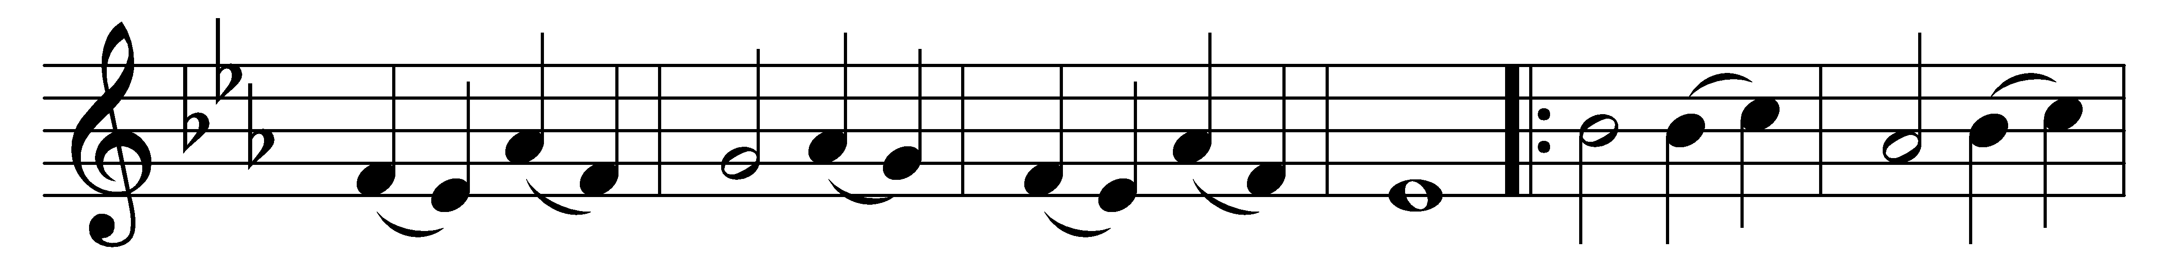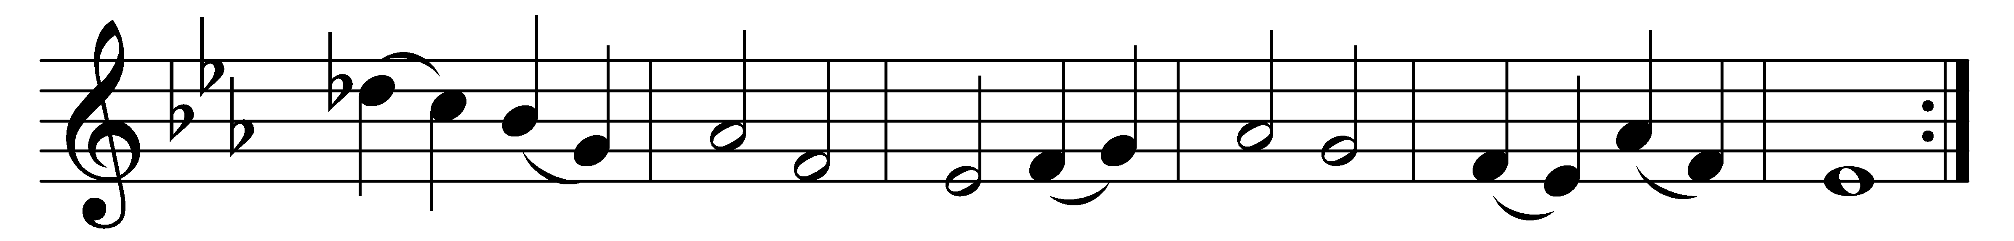

Blessed feasts of blessed martyrs,
holy women, holy men,
with affection’s recollections
greet we your return again.
Worthy deeds they wrought, and wonders,
worthy of the Name they bore;
we, with meetest praise and sweetest,
honour them for evermore.

Faith prevailing, hope unfailing,
loving Christ with single heart,
thus they, glorious and victorious,
bravely bore the martyr’s part,
by contempt of every anguish,
by unyielding battle done;
victors at the last, they triumph,
with the host of angels one.

Therefore, ye that reign in glory,
fellow-heirs with Christ on high,
join to ours your supplication
when before him we draw nigh,
praying that, this life completed,
all its fleeting moments past,
by his grace we may be worthy
of eternal bliss at last.

Words: Latin, 12th century, translated by John Mason Neale (1818-1866)
Music: Melody from Laudi Spirituali, 14th century, adapted and harmonised by Charles Burney (1726-1814)

