Come sing, ye choirs exultant Hymnal 1982 no. 235
Melody: Ach Gott, vom Himmelreiche 7 6. 7 6. D.
British spelling
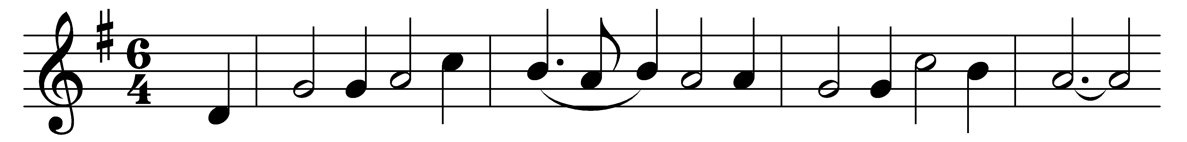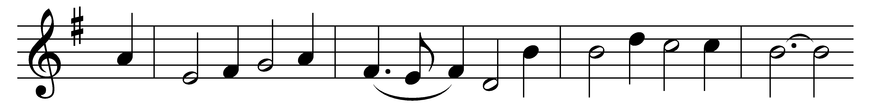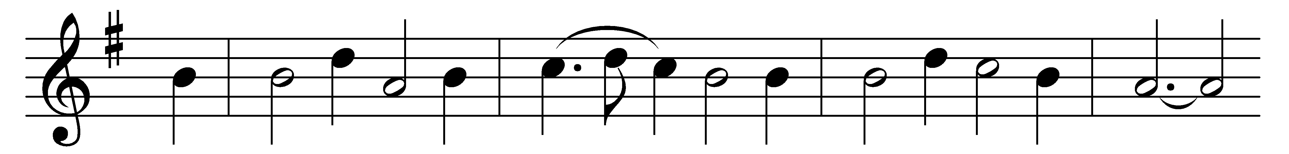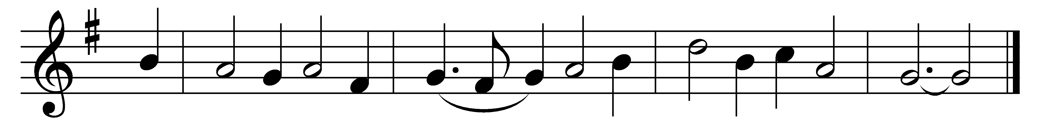

Come sing, ye choirs exultant,
those messengers of God,
through whom the living Gospels
came sounding all abroad!
Whose voice proclaimed salvation
that poured upon the night,
and drove away the shadows,
and filled the world with light.

In one harmonious witness
the chosen four combine,
while each his own commission
fulfils in every line;
as, in the prophet’s vision
from out the amber flame
in mystic form and image
four living creatures came.

Foursquare on this foundation
the Church of Christ remains,
a house to stand unshaken
by floods or winds or rains.
How blest this habitation
of gospel liberty,
where with a holy people
God dwells in Unity.

Words: Latin, 12th century, translated by Jackson Mason (1833-1889)
Music: Melody by Michael Praetorius (1571-1621), harmony by George Ratcliffe Woodward (1848-1934), based on Praetorius

