Spirit of mercy, truth, and love Hymnal 1982 no. 229 Melody: Melcombe L.M.
Words from AMNS
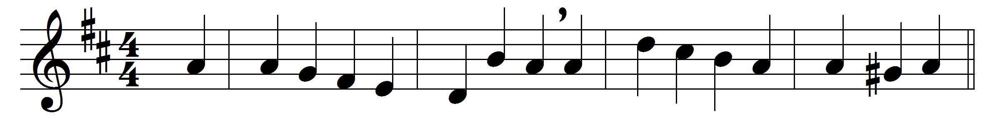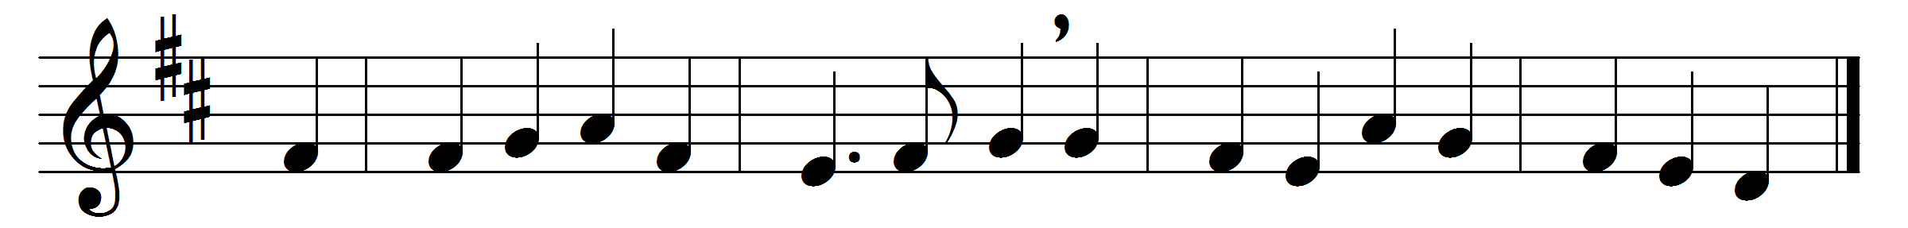

Spirit of mercy, truth, and love,
O shed thine influence from above,
and still from age to age convey
the wonders of this sacred day.

In every clime, by every tongue,
be God’s surpassing glory sung;
let all the listening earth be taught
the acts our great Redeemer wrought.

Unfailing comfort, heavenly guide,
still o’er thy holy Church preside;
still let mankind thy blessings prove,
Spirit of mercy, truth, and love.

Words: Anonymous, Psalms, Hymns and Anthems, 1774
Music: Samuel Webbe the elder (1740-1816)

