The Lord ascendeth up on high Hymnal 1982 no. 219
Melody: Ach Herr, du allerhöchster Gott 8 8 7. 8 8 7.

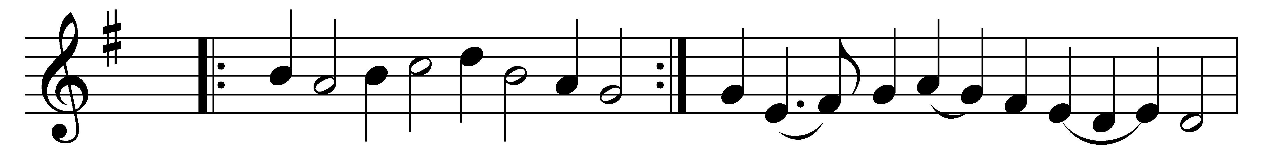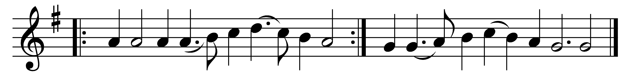

The Lord ascendeth up on high,
the Lord hath triumphed gloriously,
in power and might excelling;
the grave and hell are captive led.
Lo! he returns, our glorious Head,
to his eternal dwelling.

The heavens with joy receive their Lord,
by saints, by angel hosts adored;
O day of exultation!
O earth, adore thy glorious King!
His rising, his ascension sing
with grateful adoration!

Our great High Priest hath gone before,
upon his Church his grace to pour;
and still his love he giveth.
O may our hearts to him ascend;
may all within us upward tend
to him who ever liveth!

Words: Arthur Tozer Russell (1806-1874)
Music: Michael Praetorius (1571-1621)

