A hymn of glory let us sing Hymnal 1982 no. 218 Melody: Deo gracias (as at hymn 449) L.M.

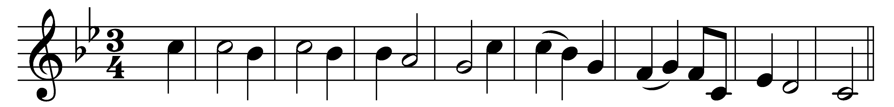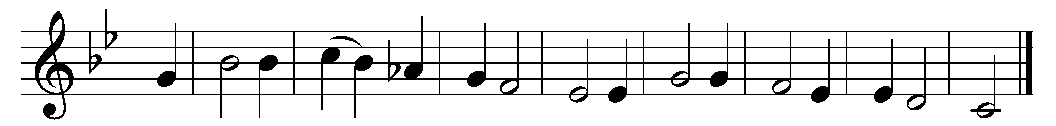

A hymn of glory let us sing,
new hymns throughout the world shall ring;
by a new way none ever trod
Christ takes his place – the throne of God!

You are a present joy, O Lord;
you will be ever our reward;
and great the light in you we see
to guide us to eternity.

O risen Christ, ascended Lord,
all praise to you let earth accord,
who are, while endless ages run,
with Father and with Spirit, One.

Words: The Venerable Bede (673-735), vv. 1-2 translated by Elizabeth Rundle Charles (1828-1896), v. 3 translated by Benjamin Webb (1819-1885)
Music: English ballad melody, Trinity College MS, 15th century, harmony from Hymns Ancient and Modern Revised

