See the Conqueror mounts in triumph Hymnal 1982 no. 215 Melody: In Babilone 8 7. 8 7. D.

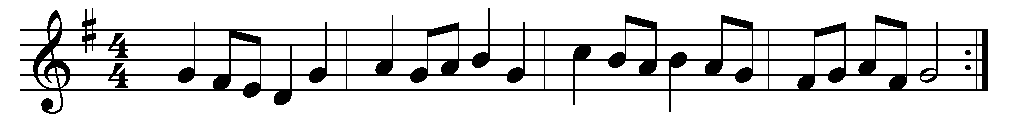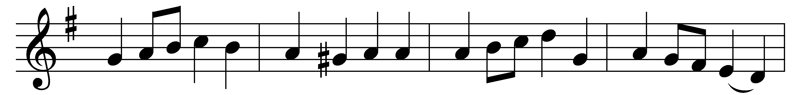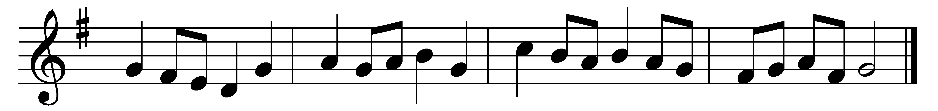

See the Conqueror mounts in triumph;
see the King in royal state,
riding on the clouds, his chariot,
to his heavenly palace gate!
Hark! the choirs of angel voices
joyful alleluias sing,
and the portals high are lifted
to receive their heavenly King.

He who on the cross did suffer,
he who from the grave arose,
he has vanquished sin and Satan;
he by death has spoiled his foes.
While he lifts his hands in blessing,
he is parted from his friends;
while their eager eyes behold him,
he upon the clouds ascends.

Thou hast raised our human nature
on the clouds to God’s right hand:
there we sit in heavenly places,
there with thee in glory stand.
Jesus reigns, adored by angels;
Man with God is on the throne;
mighty Lord, in thine ascension,
we by faith behold our own.

Words: Christopher Wordsworth (1807-1885)
Music: Melody from Oude en Nieuwe Hollantse Boerenlities en Contradansen, 1710, harmony by Charles Winfred Douglas (1867-1944)

