Come away to the skies Hymnal 1982 no. 213 Melody: Middlebury 6 6 9. 6 6 9.
British spelling
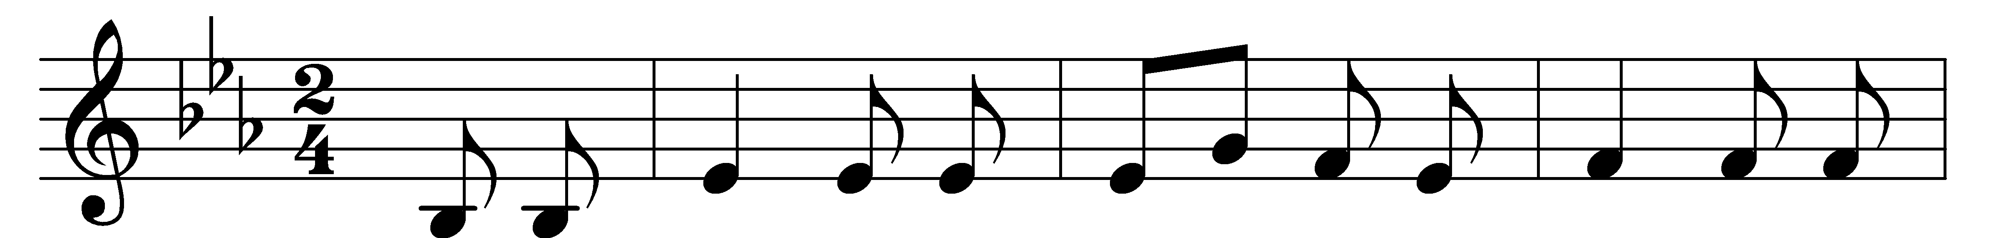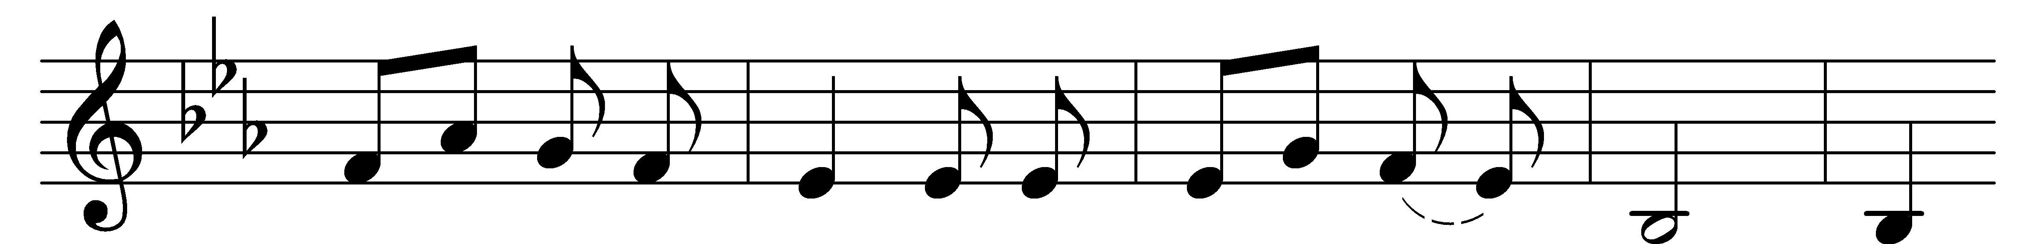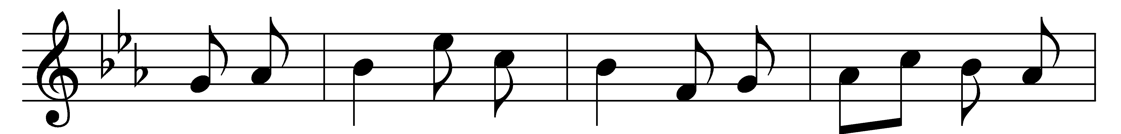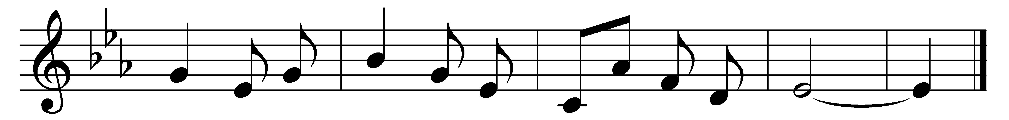
Come away to the skies,
my beloved, arise
and rejoice in the day thou wast born;
on this festival day,
come exulting away,
and with singing to Zion return.

Now with singing and praise,
let us spend all the days,
by our heavenly Father bestowed,
while his grace we receive
from his bounty, and live
to the honour and glory of God.

For the glory we were
first created to share,
both the nature and kingdom divine!
Now created again
that our lives may remain,
throughout time and eternity thine.

We with thanks do approve
the design of that love
which hath joined us to Jesus’ Name;
so united in heart,
let us nevermore part,
till we meet at the feast of the Lamb.

Hallelujah we sing,
to our Father and King,
and his rapturous praises, repeat:
to the Lamb that was slain,
hallelujah again,
sing, all heaven, and fall at his feet.

Words: Charles Wesley (1707-1788)
Music: Melody from The Southern Harmony, 1835

