On earth has dawned this day of days Hymnal 1982 no. 201
Melody: Erschienen ist der herrlich Tag L.M. with Alleluia
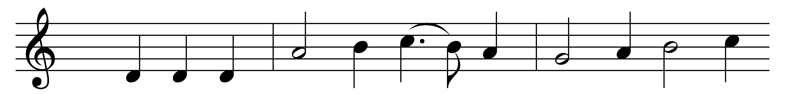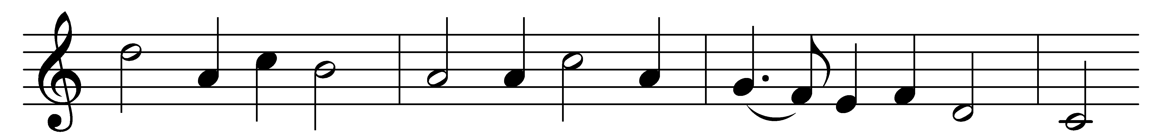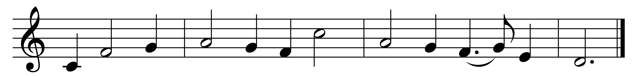

On earth has dawned this day of days,
whereon the faithful give God praise!
For Christ is risen from the tomb,
and light and joy have conquered doom. Alleluia!

At early morn, with spices rare,
the women three assembled there,
all to anoint fair Mary’s Son,
who over death had victory won. Alleluia!

‘Whom seek ye here?’ the angel said;
‘The Lord is risen from the dead;
see where he lay; let joy begin,
the tomb is empty: enter in!’ Alleluia!

So let our songs to heaven wing,
the vault with alleluias ring,
in praise of Christ, our risen Lord;
new life to all he doth afford. Alleluia!

Words: Nikolaus Hermann (1480?-1561), translated by Charles Sanford Terry (1864-1936)
Music: Nikolaus Hermann (1480?-1561)

