Father, we praise thee, now the night is over Hymnal 1982 no. 1
Melody: Christe sanctorum 11 11. 11 5.
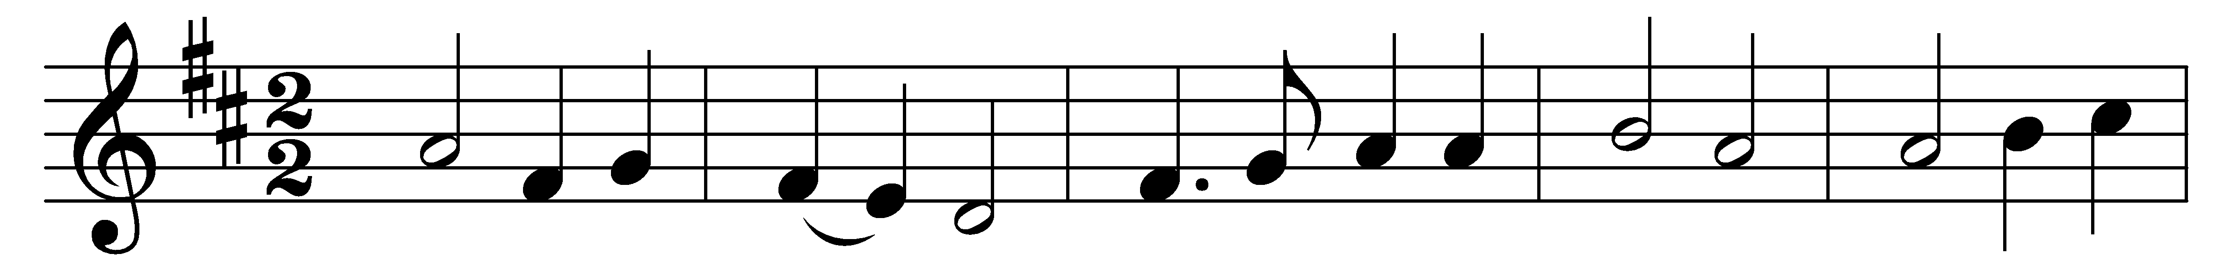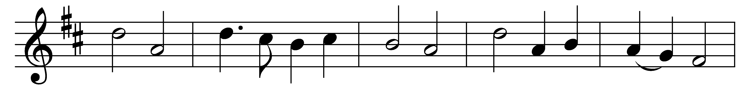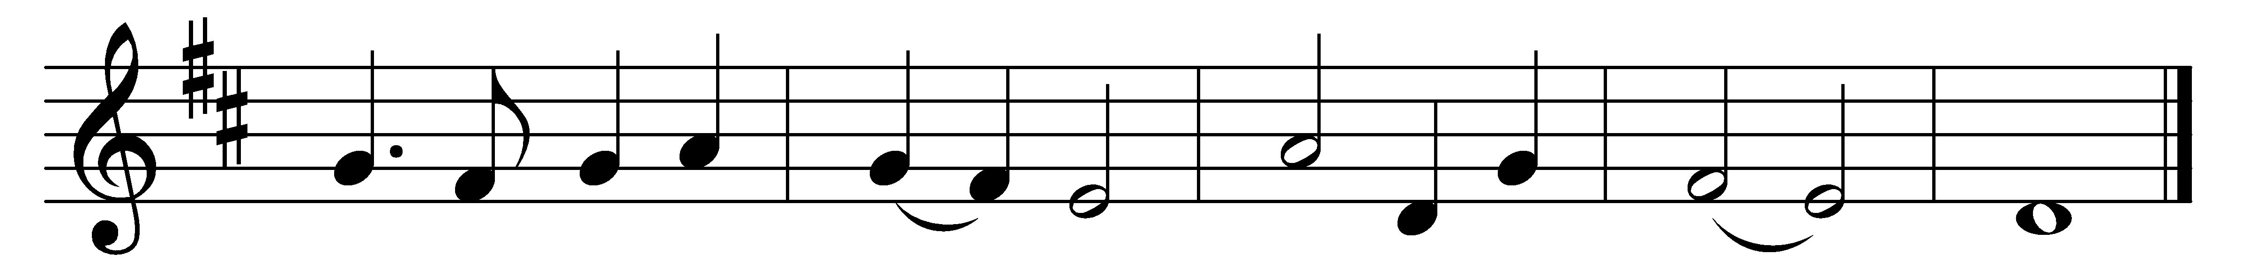

Father, we praise thee, now the night is over,
active and watchful, stand we all before thee;
singing we offer, prayer and meditation:
thus we adore thee.

Monarch of all things, fit us for thy mansions;
banish our weakness, health and wholeness sending;
bring us to heaven, where thy saints united
joy without ending.

All holy Father, Son and equal Spirit,
Trinity blessèd, send us thy salvation;
thine is the glory, gleaming and resounding
through all creation.

Words: Percy Dearmer (1867-1936)
Music: From Antiphoner, 1681

