This joyful Eastertide Hymnal 1982 no. 192 Melody: Vruechten 6 7. 6 7. with refrain

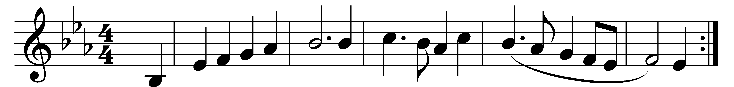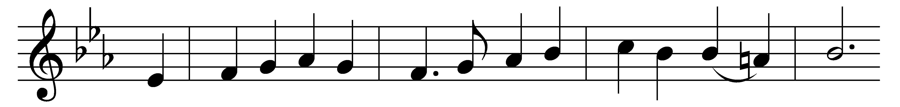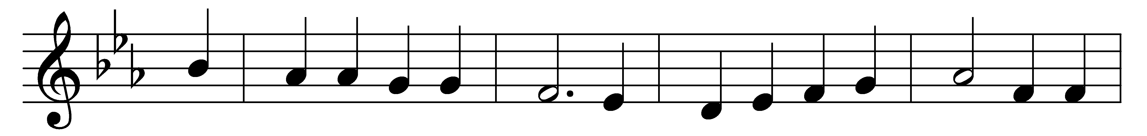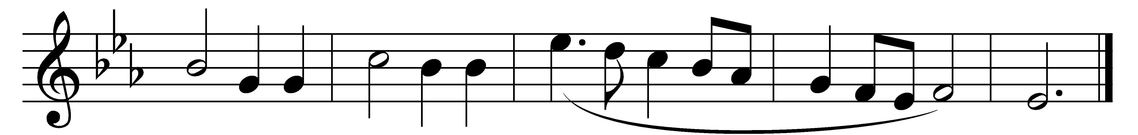

This joyful Eastertide,
away with sin and sorrow!
My Love, the Crucified,
hath sprung to life this morrow.
(Refrain:) Had Christ, that once was slain,
ne’er burst his three-day prison,
our faith had been in vain;
but now is Christ arisen,
arisen, arisen, arisen.

Death’s flood hath lost its chill,
since Jesus crossed the river:
Lord of all life, from ill
my passing life deliver. (Refrain)

My flesh in hope shall rest,
and for a season slumber,
till trump from east to west
shall wake the dead in number. (Refrain)

Words: George Ratcliffe Woodward (1848-1934)
Music: Melody from Psalmen, 1685, harmonised by Charles Wood (1866-1926)

