Alleluia, alleluia! Hymnal 1982 no. 191 Melody: Hyfrydol 8 7. 8 7. D.
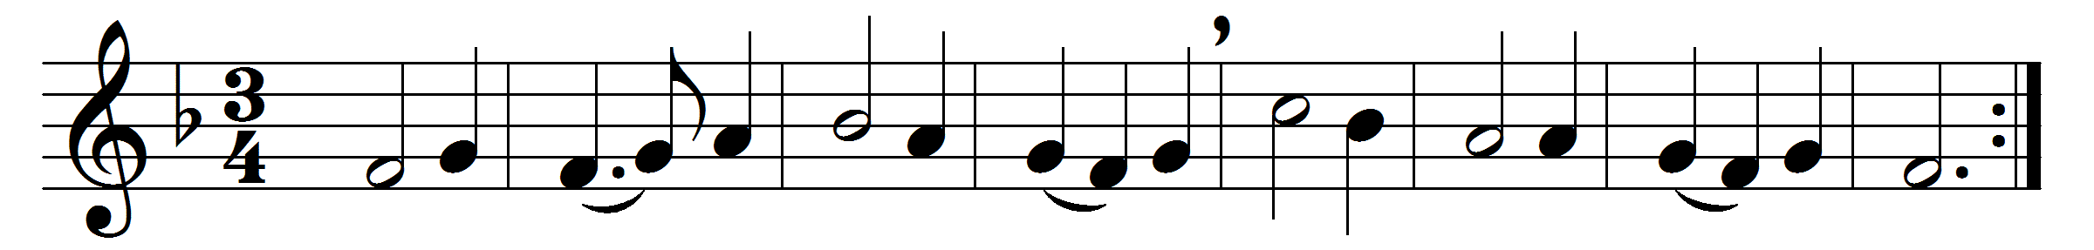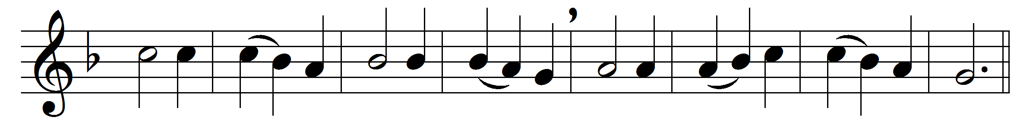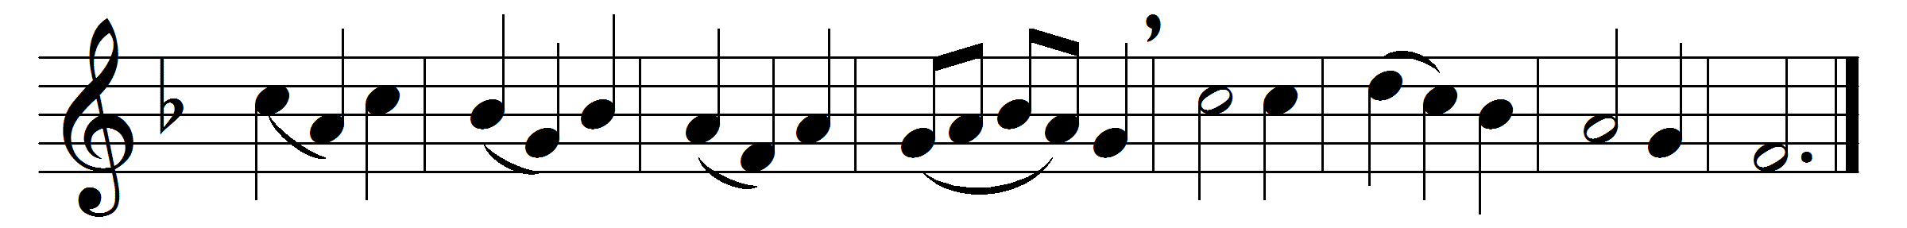

Alleluia, alleluia!
Hearts and voices heavenward raise:
sing to God a hymn of gladness,
sing to God a hymn of praise.
He, who on the cross a victim,
for the world’s salvation bled,
Jesus Christ, the King of glory,
now is risen from the dead.

Now the iron bars are broken,
Christ from death to life is born,
glorious life, and life immortal,
on his resurrection morn.
Christ has triumphed, and we conquer
by his mighty enterprise:
we with him to life eternal
by his resurrection rise.

Christ is risen, Christ, the first-fruits
of the holy harvest-field,
which will all its full abundance
at his second coming yield:
then the golden ears of harvest
will their heads before him wave,
ripened by his glorious sunshine
from the furrows of the grave.

Christ is risen, we are risen!
Shed upon us heavenly grace,
rain and dew and gleams of glory
from the brightness of thy face;
that, with hearts in heaven dwelling,
we on earth may fruitful be,
and by angel hands be gathered,
and be ever, Lord, with thee.

Alleluia, alleluia!
Glory be to God on high;
Alleluia! to the Savior
who has won the victory;
Alleluia! to the Spirit,
fount of love and sanctity:
Alleluia, alleluia!
to the Triune Majesty.

Words: Christopher Wordsworth (1807-1885)
Music: Melody by Rowland Hugh Prichard (1811-1887)

