Christ Jesus lay in death’s strong bands Hymnal 1982 no. 185
Melody: Christ lag in Todesbanden 8 7. 8 7. 7 8. 7 4.

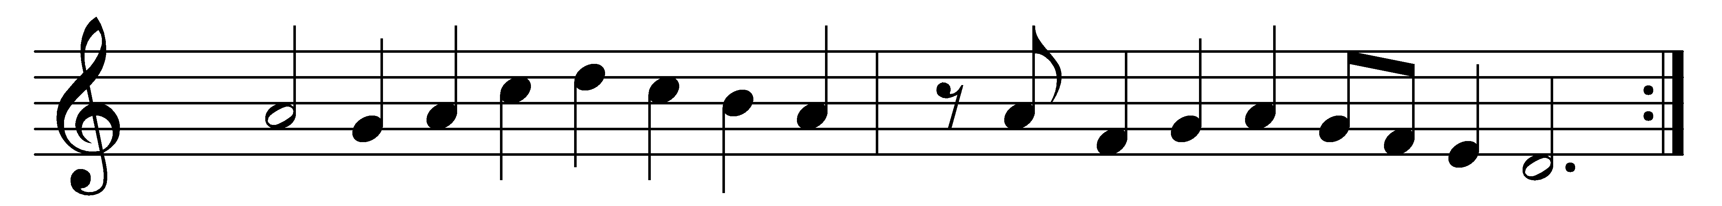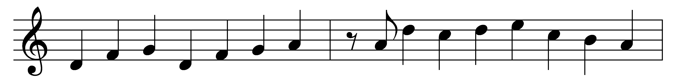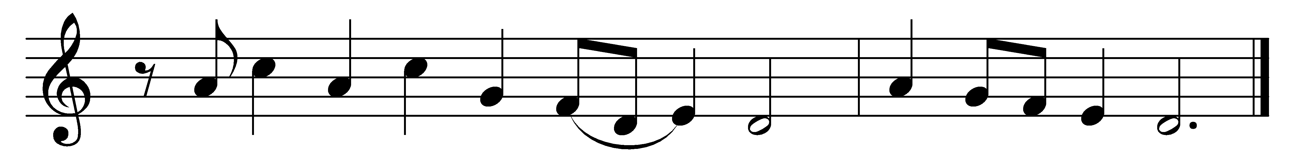

Christ Jesus lay in death’s strong bands
for our offenses given;
but now at God’s right hand he stands
and brings us life from heaven;
therefore let us joyful be,
and sing to God right thankfully
loud songs of alleluia! Alleluia!

It was a strange and dreadful strife
when life and death contended;
the victory remained with life,
the reign of death was ended;
stripped of power, no more he reigns,
an empty form alone remains;
his sting is lost for ever! Alleluia!

So let us keep the festival
to which the Lord invites us;
Christ is himself the joy of all,
the sun that warms and lights us;
by his grace he doth impart
eternal sunshine to the heart;
the night of sin is ended! Alleluia!

Then let us feast this holy day
on the true bread of heaven;
the word of grace hath purged away
the old and wicked leaven;
Christ alone our souls will feed,
he is our meat and drink indeed;
faith lives upon no other! Alleluia!

Words: Martin Luther (1483-1546), translated by Richard Massie (1800-1887)
Music: Melody from Geystliche gesangk Buchleyn, 1524, harmony based on Hans Leo Hassler (1564-1612)

