Christ the Lord is risen again! Hymnal 1982 no. 184
Melody: Christ ist erstanden 7 7. 7 7. 4 with refrain

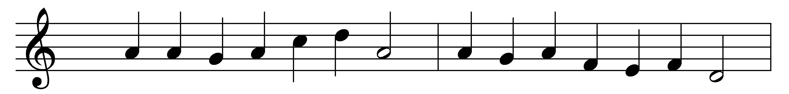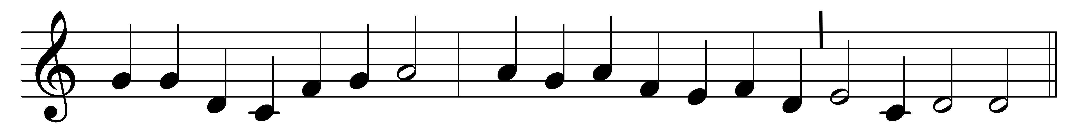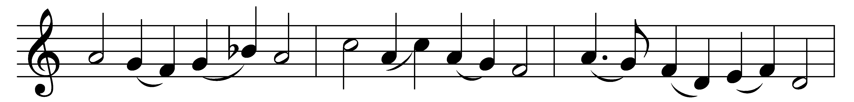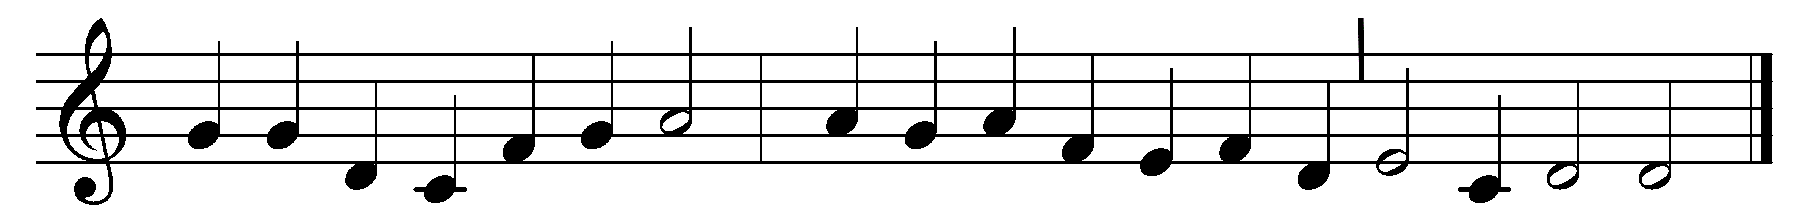

Christ the Lord is risen again!
Christ has broken every chain!
Now through all the world it rings
that the Lamb is King of kings.
Alleluia!

(Refrain:) Alleluia, alleluia, alleluia!
Christ, our Paschal lamb indeed,
Christ, today your people feed.
Alleluia!

He who gave for us his life,
who for us endured the strife,
takes our sin and guilt away
that with angels we may say:
Alleluia! (Refrain)

He who bore all pain and loss
comfortless upon the cross
is exalted now to save,
wresting victory from the grave.
Alleluia! (Refrain)

Words: Michael Weisse (1480-1534), translated by Catherine Winkworth (1827-1878)
Music: Melody from Geistliche Lieder, 1533, harmony based on Hans Leo Hassler (1564-1612)

