Awake and sing the song Hymnal 1982 no. 181 Melody: St Ethelwald S.M.
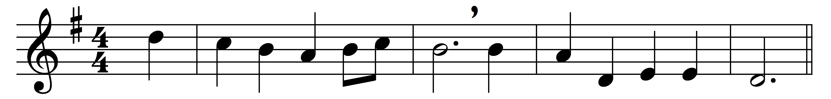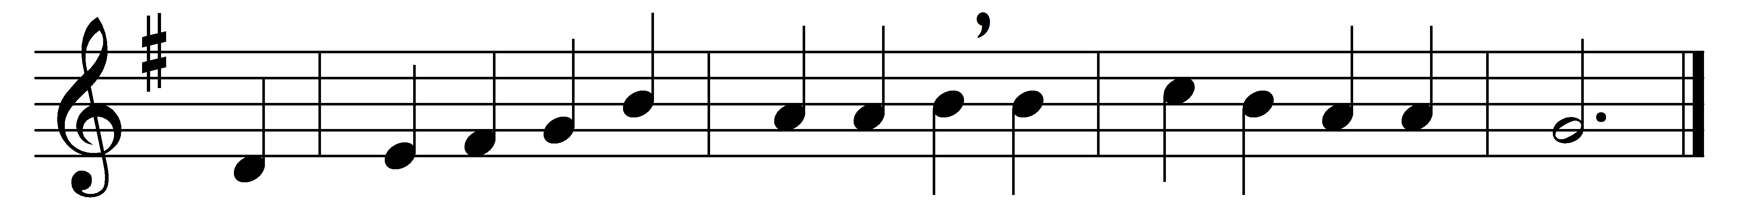

Awake and sing the song
of Moses and the Lamb;
wake every heart and every tongue
to praise the Savior’s name.

Sing of his dying love,
his resurrection power;
sing how he intercedes above
for those whose sins he bore.

You pilgrims on the road
to Zion’s city, sing,
rejoicing in the Lamb of God,
to Christ th’ eternal King.

Soon shall each raptured tongue
his endless praise proclaim,
and sing in sweeter notes the song
of Moses and the Lamb.

Words: William Hammond (1719-1783)
Music: William Henry Monk (1823-1889)

