‘Welcome, happy morning!’ age to age shall say Hymnal 1982 no. 179
Melody: Fortunatus 11 11. 11 11. 11. British spelling
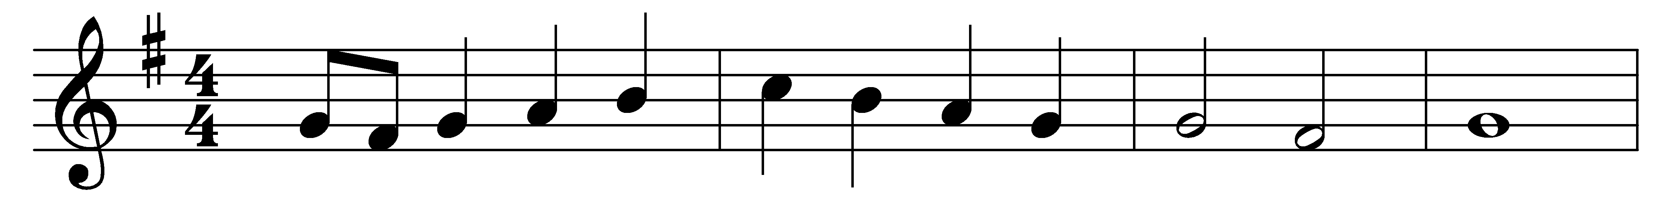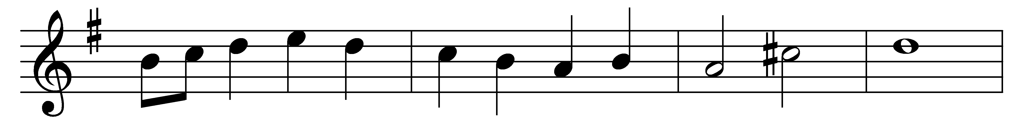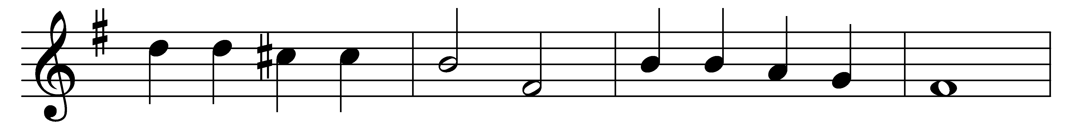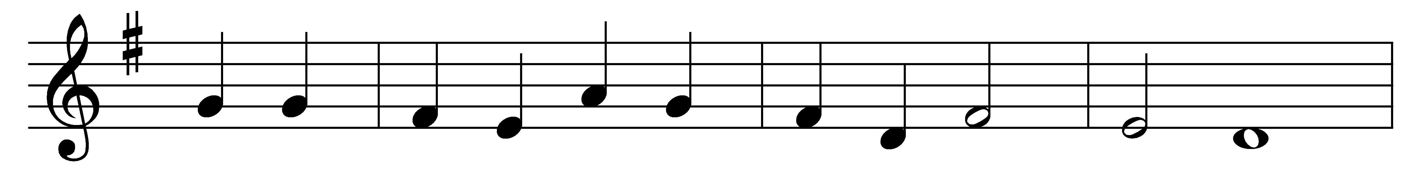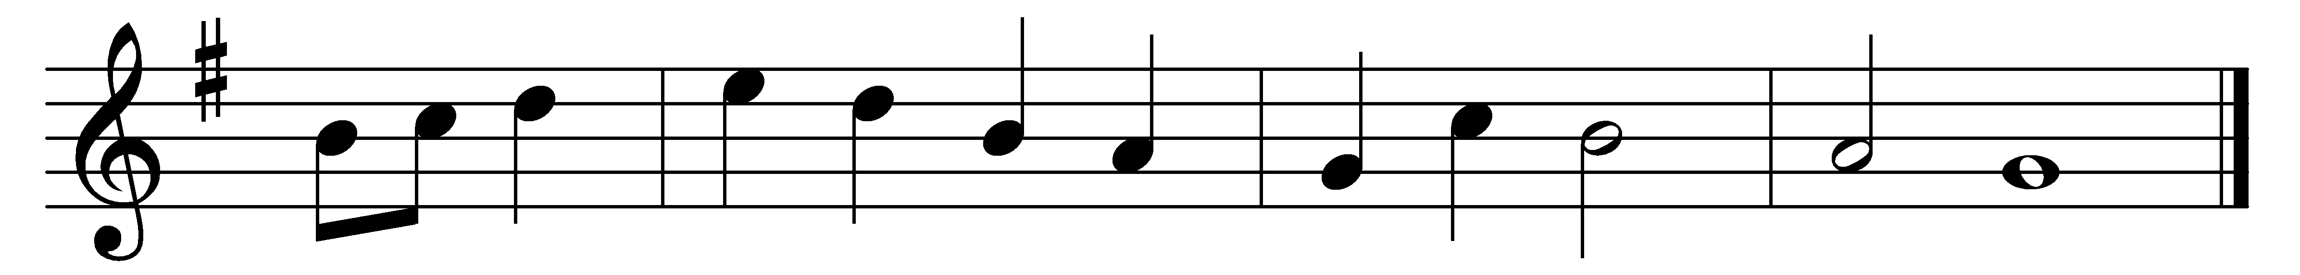

‘Welcome, happy morning!’ age to age shall say:
hell today is vanquished, heaven is won today!
Lo! the dead is living, God for evermore!
Him their true Creator, all his works adore!
Refrain: ‘Welcome, happy morning!’ age to age shall say.

Earth her joy confesses, clothing her for spring,
all fresh gifts returned with her returning King:
bloom in every meadow, leaves on every bough,
speak his sorrow ended, hail his triumph now. (Refrain)

Months in due succession, days of lengthening light,
hours and passing moments praise thee in their flight.
Brightness of the morning, sky and fields and sea,
Vanquisher of darkness, bring their praise to thee. (Refrain)

Maker and Redeemer, life and health of all,
thou from heaven beholding human nature’s fall,
of the Father’s Godhead true and only Son,
mankind to deliver, manhood didst put on. (Refrain)

Thou, of life the author, death didst undergo,
tread the path of darkness, saving strength to show;
come then, true and faithful, now fulfil thy word,
’tis thine own third morning! rise, O buried Lord! (Refrain)

Loose the souls long prisoned, bound with Satan’s chain;
all that now is fallen raise to life again;
show thy face in brightness, bid the nations see;
bring again our daylight: day returns with thee! (Refrain)

Words: Venantius Honorius Fortunatus (540?-600?), translated by John Ellerton (1826-1893)
Music: Arthur Seymour Sullivan (1842-1900)

