Wilt thou forgive that sin, where I begun Hymnal 1982 no. 140
Melody: Donne 10 10. 10 10. 8 4.
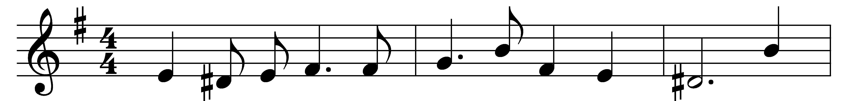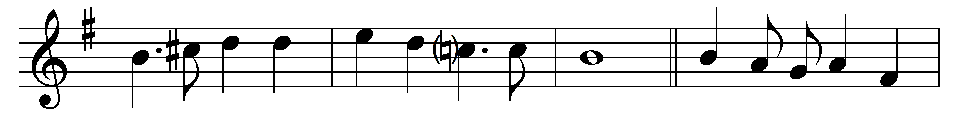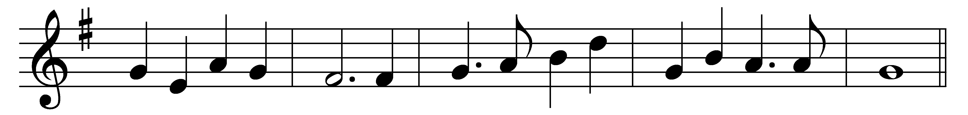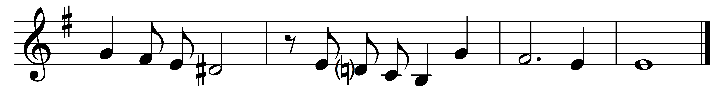

Wilt thou forgive that sin, where I begun,
which is my sin, though it were done before?
Wilt thou forgive those sins through which I run,
and do run still, though still I do deplore?
When thou hast done, thou hast not done,
for I have more.

Wilt thou forgive that sin, by which I won
others to sin, and made my sin their door?
Wilt thou forgive that sin which I did shun
a year or two, but wallowed in a score?
When thou hast done, thou hast not done,
for I have more.

I have a sin of fear that when I’ve spun
my last thread, I shall perish on the shore;
swear by thyself, that at my death thy Son
shall shine as he shines now, and heretofore.
And having done that, thou hast done,
I fear no more.

Words: John Donne (1573-1631)
Music: John Hilton (1599-1657)

