“I come,” the great Redeemer cries Hymnal 1982 no. 116 Melody: This Endris Nyght C.M.
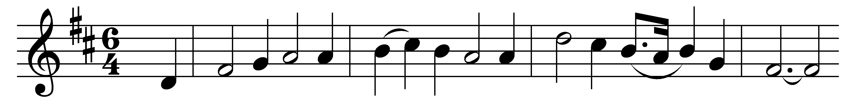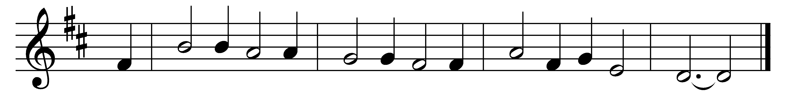

“I come,” the great Redeemer cries,
“to do thy will, O Lord!”
At Jordan’s stream, behold! He seals
the sure prophetic word.

“Thus it becomes us to fulfill
all righteousness,” he said.
Then, faithful to the Lord’s commands,
through Jordan’s flood was led.

Hark, a glad voice! The Father speaks
from heaven’s exalted height:
“This is my Son, my well-beloved
in whom I take delight.”

The Savior Jesus, well-beloved!
His Name we will profess,
like him desirous to fulfill
God’s will in righteousness.

No more we’ll count ourselves our own
but his in bonds of love.
Oh, may such bonds for ever draw
our souls to things above!

Words: Christian Hymnbook, 1865
Music: English melody

