The snow lay on the ground Hymnal 1982 no. 110 Melody: Venite adoremus Irregular metre
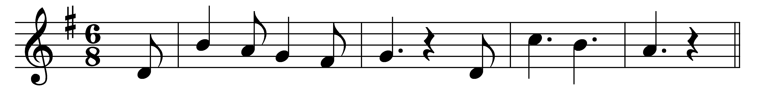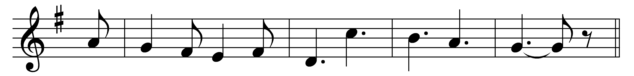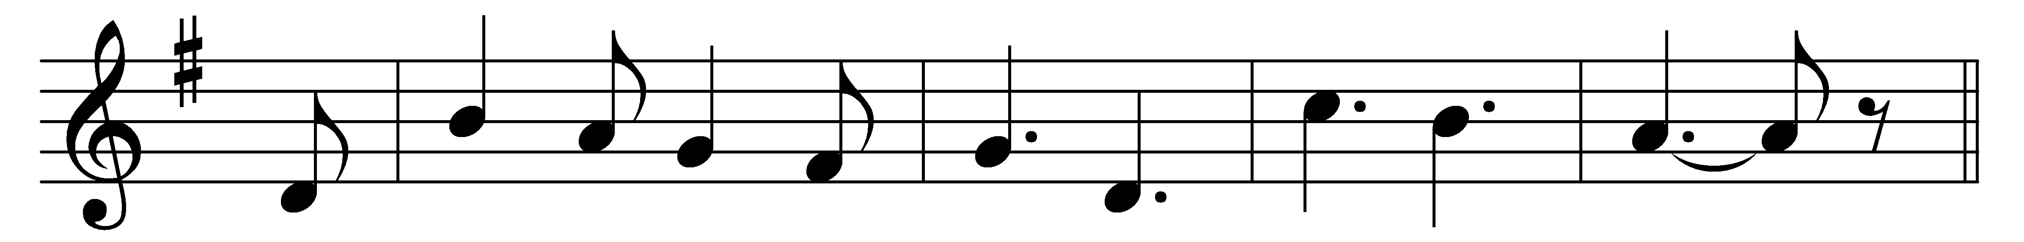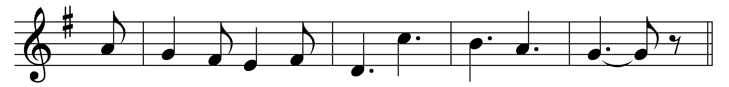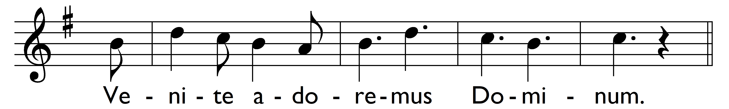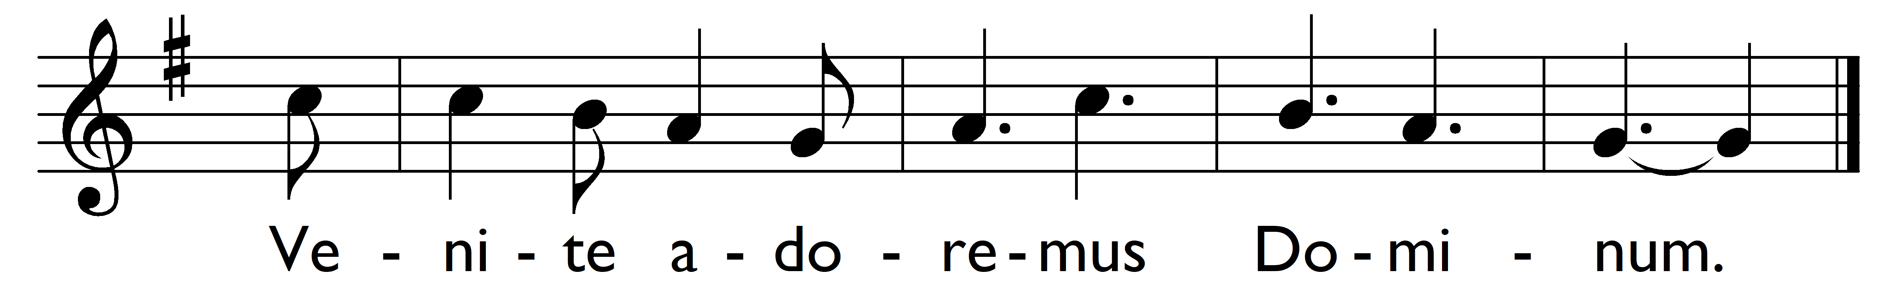

The snow lay on the ground,
the stars shone bright,
when Christ our Lord was born
on Christmas night.
Venite adoremus Dominum.
Venite adoremus Dominum.
(Refrain:) Venite adoremus Dominum.
Venite adoremus Dominum.

’Twas Mary, daughter pure
of holy Anne,
that brought into this world
the God made man.
She laid him in a stall
at Bethlehem;
the ass and oxen shared
the roof with them.
(Refrain)

Saint Joseph, too, was by
to tend the child;
to guard him, and protect
his mother mild;
the angels hovered round,
and sang this song,
Venite adoremus Dominum.
(Refrain)

And thus that manger poor
became a throne;
for he whom Mary bore
was God the Son.
O come, then, let us join
the heavenly host;
to praise the Father, Son,
and Holy Ghost.
(Refrain)

Words: Anonymous, 19th century
Music: Melody adapted by Charles Winfred Douglas (1867-1944)

