New every morning is the love Hymnal 1982 no. 10 Melody: Kedron L.M.

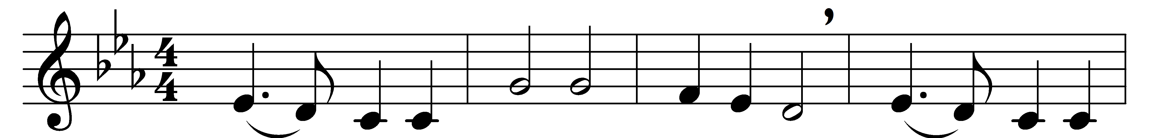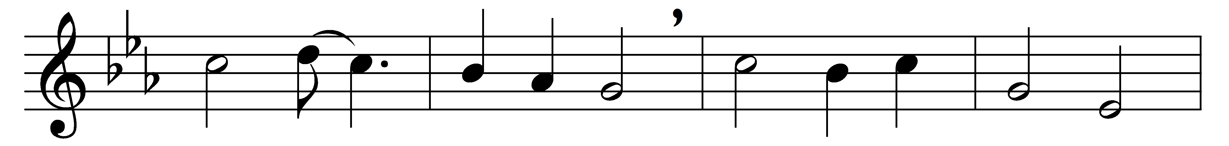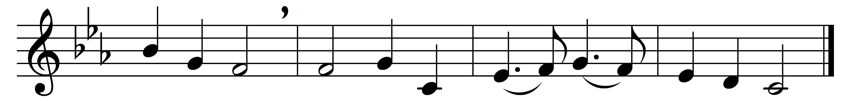

New every morning is the love
our wakening and uprising prove;
through sleep and darkness safely brought,
restored to life and power and thought.

New mercies, each returning day,
around us hover while we pray;
new perils past, new sins forgiven,
new thoughts of God, new hopes of heaven.

If on our daily course our mind
be set to hallow all we find,
new treasures still, of countless price,
God will provide for sacrifice.

Old friends, old scenes, will lovelier be,
as more of heaven in each we see;
some softening gleam of love and prayer
shall dawn on every cross and care.

The trivial round, the common task,
will furnish all we ought to ask:
room to deny ourselves; a road
to bring us daily nearer God.

Only, O Lord, in thy dear love,
fit us for perfect rest above;
and help us, this and every day,
to live more nearly as we pray.

Words: John Keble (1792-1866)
Music: Melody attributed to Elkanah Kelsay Dare (1782-1826), harmony based on The Southern Harmony (1835)

