Away in a manger, no crib for his bed Hymnal 1982 no. 101 Melody: Cradle Song 11 11. 11 11.
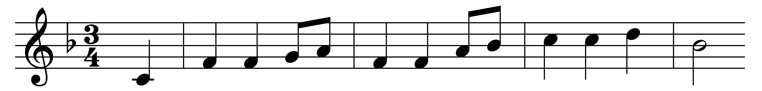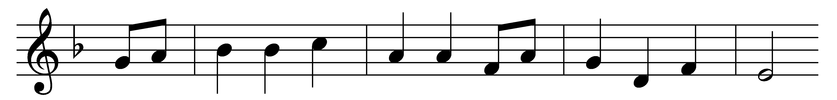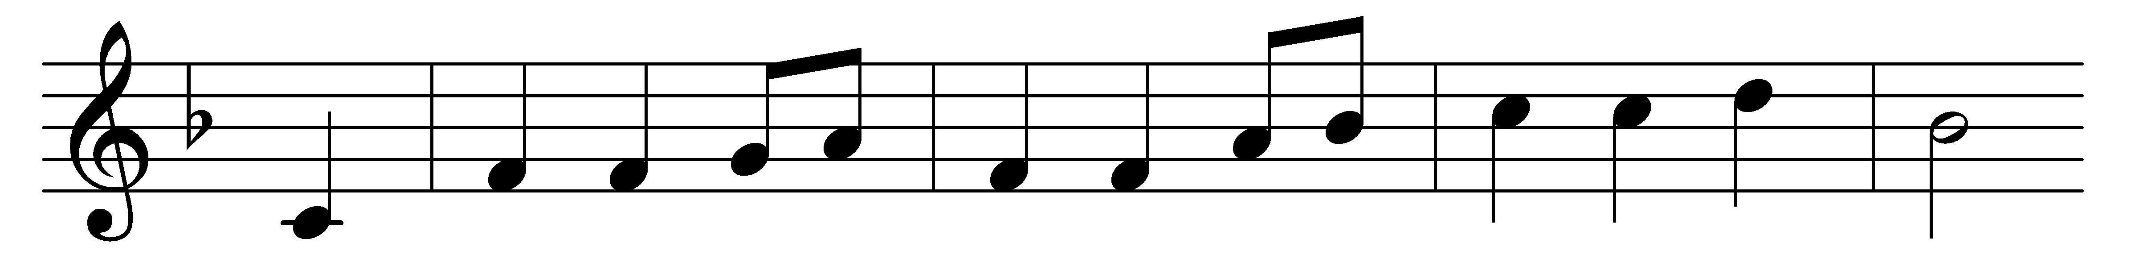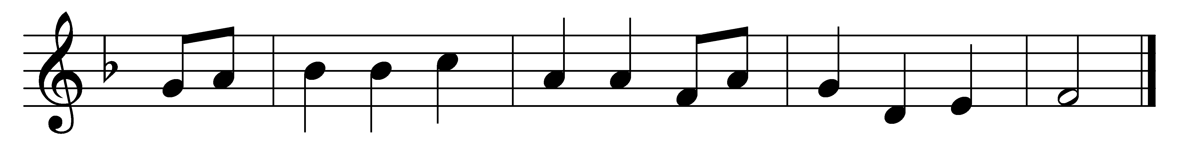

Away in a manger, no crib for his bed,
the little Lord Jesus laid down his sweet head.
The stars in the bright sky looked down where he lay;
the little Lord Jesus asleep on the hay.

The cattle are lowing, the baby awakes,
but little Lord Jesus no crying he makes.
I love thee, Lord Jesus! Look down from the sky,
and stay by my side until morning is nigh.

Be near me, Lord Jesus; I ask thee to stay
close by me for ever, and love me I pray.
Bless all the dear children in thy tender care,
and fit us for heaven to live with thee there.

Words: Traditional
Music: Melody by William James Kirkpatrick (1838-1921)

